**Accessing Unami Databases (usernames and passwords)**

The library web page’s URL address is: <http://www.cbsd.org/unamilibrary>

You should always begin your “electronic research” at the reliable and timely resources available through our **online databases**. These databases are available from home with the proper username and password.

 Password: research

This database most accurately reflects traditional classroom curriculums, as well as contemporary issues. It is an excellent source for articles from *premiere middle school and high school reference books*, magazine/newspaper articles, and audio/video clips.

[](https://go.gale.com/ps/i.do?p=MSIC&sw=w&u=lenape_unamims&v=2.1&pg=BasicSearch&it=static&sid=MSIC) Password: research

Password: research

Full reference sets in a digital form. Includes American Decades Primary Source set and others.

[](https://go.gale.com/ps/i.do?p=OVIC&sw=w&u=lenape_unamims&v=2.1&pg=BasicSearch&it=static&sid=OVIC) **Password: research**

Topics are organized under **key social issues**. It contains full text articles from the Opposing Viewpoints books that give both sides to an argument, reference books, statistics, links to reliable web sites, primary documents, and magazine and newspaper articles.

InfoTrac Student Edition Provides access to magazines, newspapers and others Password: research

Trouble Accessing any of the Gale Databases? Use CLASSLINKS -Gale Databases in Library Resources

[**America's Historical Newspapers (1690 - 2000)**](https://infoweb.newsbank.com/apps/news/americas-historical-newspapers?p=EANX-K12)

Find **news articles** covering topics in government, politics, social issues, culture, literature discoveries, inventions and more from hundreds of **primary sources** . Search using either the **timeline or topic search** to easily find news and **eyewitness accounts and pro/con articles of events, issues and daily life** in the colonies or during the Revolutionary War, westward expansion, the Civil War, Reconstruction, industrialization, the Progressive Era, World War I, the Great Depression, Vietnam War, World War II, Civil Rights Movement, Cold War, globalization and other eras. Also included are illustrations, advertisements, classifieds, birth and marriage announcements, obituaries, stories about historic people and other **articles exactly as they appeared in print** . **Username and Password: CENTRAL**

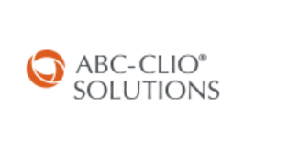 Username: Unami Password: research

ABC-CLIO Social Studies Databases: Reference sources that support the social studies curriculum. Unami subscribes to the following databases: World History: Ancient and Medieval, World History: Modern, American History, and Issues: Controversy and Society.

 Reference Encyclopedia and other sources. Username and password: cblibrary

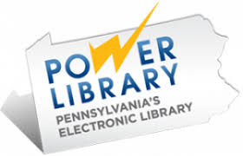The POWER Library is offered as a service of Pennsylvania's public libraries, school libraries and the State Library. It includes AP Images for up to date photographs from the AP and some other sources. It also connects you to special collections housed in Pennsylvania libraries.

(From home, you must access this database through the public library website with your public library card: <http://www.buckslib.org/>)