Reflection 

The What, Why and How of Reflection

Things we reflect upon: Test grade, career choice, college plan – (stretch and realistic), job, project, our appearance, our work, our relationships………………..etc.

Historically speaking, “Those who fail to learn from history are doomed to repeat it.” George Santayana

Or you can say, “Insanity is doing the same thing over and over again and expecting different results.”

A Guide to Reflection:

1. What was the event, activity, project that took place?
2. What were the goals of the event – and were they met?
3. Was the timeline in planning the event enough time?
4. How effective was the event?
5. How efficient was the event?
6. What level of involvement/participation was there?
7. How well orchestrated was the delegation of tasks?
8. How did each person perform with regard to the overall task? (Knowledge of Results)
9. What would you do differently if you had to do it over again?
10. Did this evoke any new ideas for the future?

Knowledge of Results

Two Keys: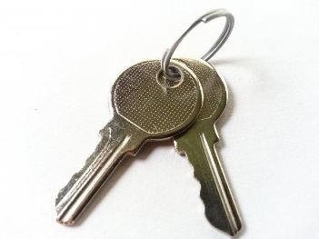

1. Immediate
2. Specific

Quick Jot What’s a B?

1. ­­­­­­­­­­­­­­­­­­­­­­­­________________ _________________________________________
2. ________________ _________________________________________
3. ________________ _________________________________________
4. ________________ _________________________________________
5. ________________ _________________________________________