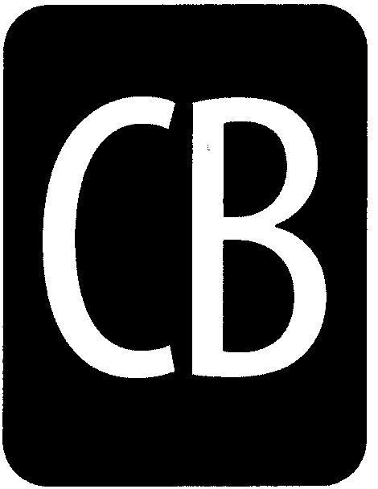

# CENTRAL BUCKS SCHOOL DISTRICT

## LEADING THE WAY

The Central Bucks Schools will provide all students with the academic and problem-solving skills   
essential for personal development, responsible citizenship, and lifelong learning.

To: **Parents of IEP Students**

From: **Special Education Supervisors**

Re: **Student Achievement Reporting System (The report card) for students with IEPs**

Date: **September 2, 2014**

Dear Parents,

This letter will explain the current procedures for using the new Central Bucks Standards Based Student Achievement Reporting System for your child, whose educational program is individualized in his/her IEP.

* For learning standards (subjects) where your child is instructed by the general education teacher in the general education classroom, progress in these areas will be reported by the general education teacher using the Central Bucks Standards Based Student Achievement Reporting System.
* For subjects where your child is receiving instruction in his/her IEP goals, current levels of achievement are reported in the IEP quarterly progress report by the special education teacher. The IEP progress report will communicate accurately your child’s growth in specific sub-skill areas within reading, writing and math.
* All IEP students will receive feedback from their general education and special education teachers in the following:

1. Success Standards (learning to learn-work habits and study skills)
2. Science and Social Studies learning standards
3. Special area classes (art, music, gym)

Individual student strengths and goal areas are also completed with your child as part of the conference report used with all students.

These arrangements have been made in order to provide you with more meaningful information regarding your child’s educational progress.