February 24th, 2021 Interact Meeting Minutes

 Reviewed three up-and-coming Interact events! More information for all will soon be released to the club and community. 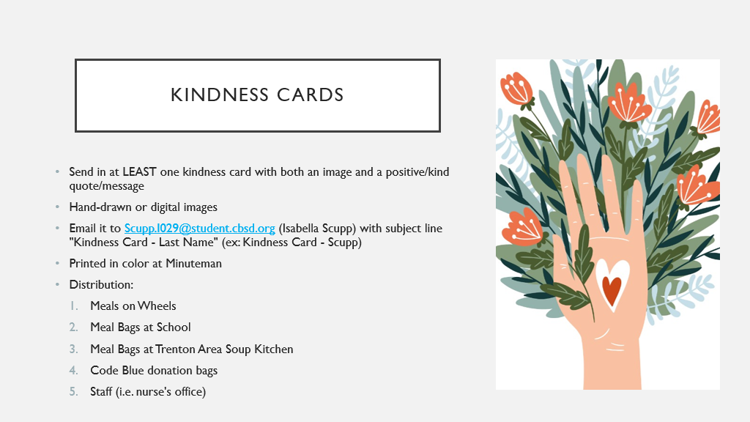

* 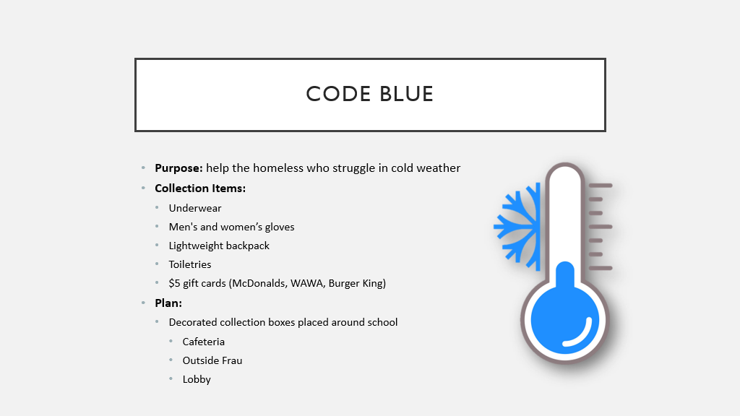More information to come!
* Flyers will be made and sent up
* Set up 3 collection boxes around school
* Example of toiletries from last year: (all must be travel size) toothbrush, toothpaste, deodorant, hand sanitizer, wet wipes, non-alcohol mouthwash, nail clippers
* Collaborate with NHS and Key Club for collection as well (perhaps 3-5 donations per hour?)

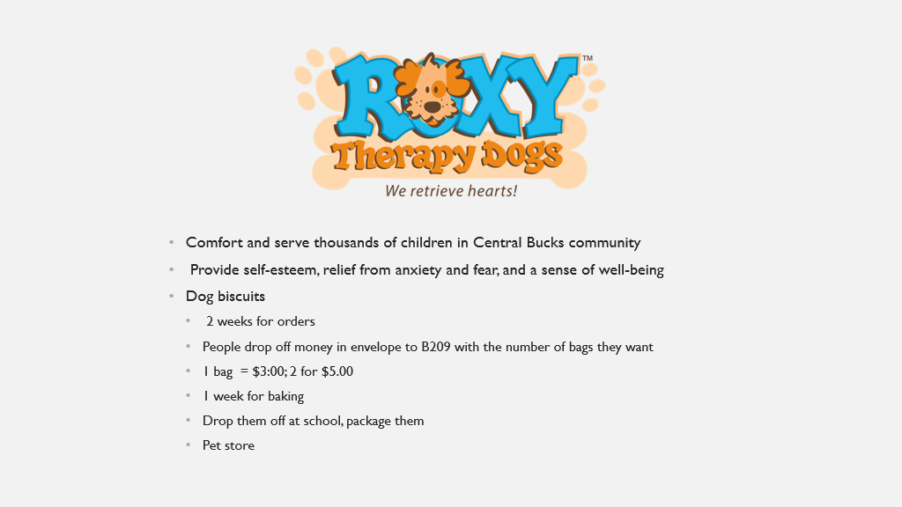

* Although we know Girls Scouts can’t sell outside the pet store we usually sell these biscuits at, we are going to ask if it is still possible for us to sell/ have a phone number for people to call/a link to the forms
* More info to come

**Next meeting: March 10th!**