***Timeline for Program Planning:***

*Portal will be open from January 3 (8 am)-February 2, 2025 (11 PM) to input course requests.*

* *The link below is a link to the CB East Program Planning page that includes course description videos and resources*

[*https://www.cbsd.org/domain/4203*](https://www.cbsd.org/domain/4203)

* *Follow the same link above to the Program of Studies (POS) Grades 9-12, which lists all courses offered at CB East and their prerequisites. The link is found toward the bottom of the page under Additional Resources.*

Sample Schedule with AP European History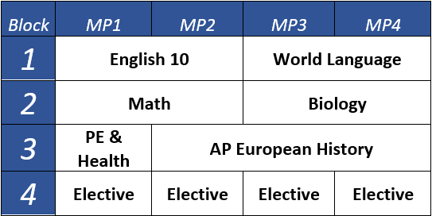

***Nuts and Bolts of Block Scheduling***

* *Four 83-minute blocks a day*
  + *Advisory and Lunch & Learn falls in between*

*block 2 and 3*

* + *Advisory Teacher = Success Plan Advisor*
* *Most academic classes are 1.0 credit (half a year)*
* *1.0 credit = 18 weeks = 2 marking periods = 1 semester*
* *.50 credit = 9 weeks = 1 marking period*
* *.25 credit = 9 weeks every other day for 1 marking period*

***Guidelines and Tips for Filling Your Schedule***

* *English MUST be taken all 4 years.*
* *4 Credits of English, Math and Social Studies are*

*required to graduate.*

* *3 Credits of Science are required to graduate and*

*Biology must be taken in 10th grade.*

* *Math and World Language MUST follow a certain*

*sequence.*

* *All 10th graders must take PE/Health 7061 or 7062*

Sample Schedule with MBIT 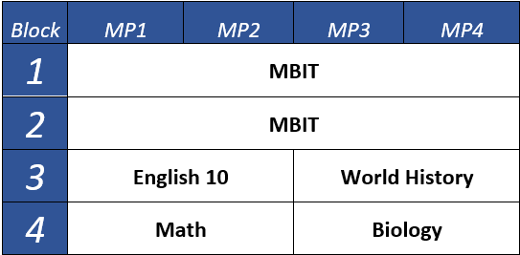

* *Prerequisites MUST be met to move on in a sequence.*
* *Pick at least 3 alternatives in case your chosen*

*electives do not fit.*

* *Be aware that Study Halls are an option if classes do*

*not fit.*

* *Music classes run ALL year EVERY OTHER DAY.*
* *MBIT is half of the school day all year either blocks*

*1-2(AM MBIT) or blocks 3-4 (PM MBIT).*

|  |  |  |  |  |
| --- | --- | --- | --- | --- |
| ***Before School Activities*** |  |  |  |  |
| *Block* | *MP1* | *MP2* | *MP3* | *MP4* |
| *1* |  |  |  |  |
| *2* |  |  |  |  |
| *3* |  |  |  |  |
| *4* |  |  |  |  |
| ***After School Activities*** |  |  |  |  |

*Please be aware that course requests are subject to section/seat availability. There is no guarantee on the time of year (i.e. marking period or semester) you may be scheduled for a requested course or elective. Complete the scheduling grid with your preferred arrangement of classes.

|  |  |  |  |  |
| --- | --- | --- | --- | --- |
| ***Alternate Course Requests*** | ***Please list up to three Alternate Course Requests in order of preference*** | | | |
|  |  |  |  |

**Frequently Asked Questions (FAQ)**

|  |  |
| --- | --- |
| **Q: How do I enter my course requests?**  A: Students will select their course requests via the Parent Portal. Instructions have been sent home from the middle schools. Program Planning resource material is available at: <https://www.cbsd.org/domain/4203>  **Q: What is the timeline for course selection?**  A: Course registration is available via the Student Portal from 1/3 – 2/2. Students may make changes to their selections from 2/3 – 3/20 through their middle school counselor. After 3/20 only critical course changes will be permitted: failure to meet a required prerequisite or a level change approved by the principal.  **Q: How many credits do I need to graduate?**  A: Students in the Class of 2028 need 27.25 credits to graduate with the standard diploma. Please see page 3 of the Program of Studies accessible at <http://www.cbsd.org/domain/387> for more information.  **Q: How many credits will I earn in my 9th grade year?**  A: Most 9th graders will earn 6.75 credits. Students will need to earn 20.25 credits through their courses in 10-12th grade and an additional .25 in Performance Assessment (Success Plan).  **Q: What is the maximum number of credits that I can take in a year?**  A: 8 credits represents a full schedule (32 units) in grades 10-12.  **Q: How do I request a study hall?**  A: There is no course number for study hall therefore you will not enter anything into the portal. In order to request a study hall, you will enter less than 8 credits (32 units) into the course registration portal. For instance, if you enter 30 units rather than 32 units you will have one .5 credit study hall for one marking period every day.  **Q: What is the purpose of a study hall?**  A: Although a study hall is not credit bearing, many students find it to be helpful to have this time during the school day to complete schoolwork. It is preferable for students to space out their study halls over three years rather than save them all for senior year. | **Q: What is the Performance Assessment Credit?**  A: Students earn .25 credit for the Success Plan - a project completed over the course of 3 years in high school under the guidance of their advisory (homeroom) teacher.  **Q: What is a prerequisite?**  A: A prerequisite is a course that a student must successfully complete in order to qualify for entry into another course. Most English, math, science, social studies, world language, and elective courses require certain letter grade prerequisites in order to progress to the next level class. Please reference your program of studies for this information.  **Q: What is the duration of the music classes?**  A: Music classes are scheduled all year long on an every other day basis (A/B day). Students who are in two Ensemble classes, for example Chorus and Concert Band, could take both all year long in the same block. If students are in only one Ensemble, they could fill the opposite A/B day with a combination of PE/Health andone of the following Music Production, Music Theory, Rock Band, Musical Technical Theater, Digital Imaging, Personal Finance, Psychology, Intro to Law, PE electives, or Study Hall.  **Q: I want to attend MBIT and am college-bound. How will I fulfill my language requirement for college admission since I only have one year of language in 9th grade and need at minimum one more?**  A: MBIT students have one elective credit available during the course of their three years in high school. All students must take Biology, Math, English and Social Studies in 10th grade, therefore it is suggested that students take their language course in 11th grade. The 11th grade courses therefore would be Math, English, Social Studies and Language. The 12th grade courses would then be Science, Math, English and Social Studies. |