Technology | Definition | Possible Teaching Application
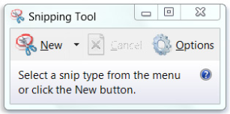  Snipping Tool: | You can capture part or your entire screen. Then you can paste the snip into another document. Open the Snipping Tool by clicking the Start button. In the search box, type Snipping Tool. In the list of results, click Snipping Tool.
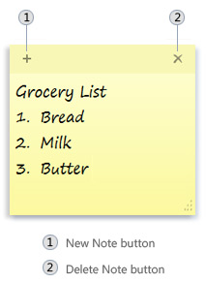  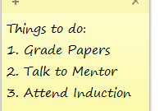  Sticky Notes: | You can use Sticky Notes to write a to-do list, jot down ideas, or brainstorm with students. Open Sticky Notes by tapping the Start button. In the search box, type Sticky Notes, and then tap Sticky Notes in the list of results.
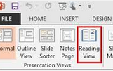  Reading View of PowerPoint: | Reading View is useful to quickly navigate the slideshow while having easy access to the task bar. This allows you to switch to other programs, like Sticky Notes. Access the Reading View on the View Tab and choose the Reading View button.
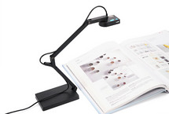  Document Camera: | Project documents, textbooks, handwritten notes, and electronic devices.  *see attached document.
PowerPoint Timers:  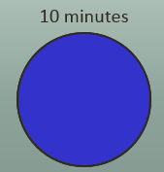 | Pre-Made PowerPoint slides that can be inserted into your presentations. These can be used to keep the pace of the lesson.

