**THIRD GRADE SUPPLIES**

* Pencil box big enough to hold all supplies
* Scissors
* Headphones in a labeled Ziploc bag
* Box of tissues
* 1 notebook
* 2 two-pocket plastic folders-*red and green*
* Whiteboard
* Whiteboard eraser/sock
* 4 Expo dry erase markers
* Optional: math flashcards
* Optional Classroom Donation: gallon or sandwich sized Ziploc bags

**FOURTH GRADE SUPPLIES**

* Small pencil sharpener
* Scissors
* Zippered pencil case that will fit all supplies
* 4 spiral notebooks
* 5 folders with pockets
* Headphones in labeled plastic bag
* 2 packages of cleaning (Clorox) wipes
* 1 container of hand sanitizer
* 1 Box of tissues

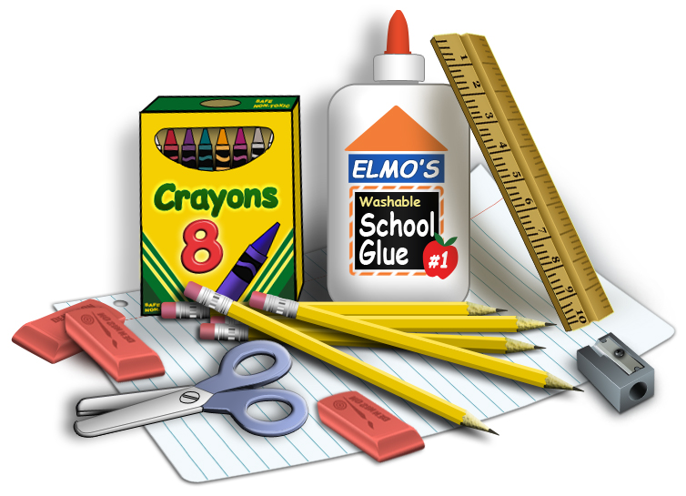

**KINDERGARTEN SUPPLIES**

* 1 box of tissues
* 1 Two-pocket folder, heavy-duty w/name
* Headphones in a Ziploc bag, labeled with your child’s name (no earbuds please)
* 1 pack (4 count) Play-Doh
* 2 Lysol or Clorox wipes

**FIRST GRADE SUPPLIES**

* 1 plastic supply box
* 5 plastic pocket folders with prongs- one each of *red, yellow, green, blue, and orange*
* 4 black Expo markers
* 1 white board eraser
* Headphones in a Ziploc bag, labeled with your child’s name
* 1 reusable water bottle (leak proof)
* 1 container of disinfecting wipes
* 2 boxes of tissues

**SECOND GRADE SUPPLIES**

* Pencil case/box big enough to hold all supplies
* 1 handheld pencil sharpener
* scissors
* 1 marble composition book
* 1 red two-pocket plastic folder
* 1 blue two-pocket plastic folder
* Whiteboard eraser/sock
* 2 boxes of tissues
* Headphones in a Ziploc bag, labeled with your child’s name
* 1 container of Clorox wipes

**KUTZ ELEMENTARY SCHOOL RECOMMENDED SCHOOL SUPPLIES 2024-2025**

Thank you for your assistance in providing the necessary materials for your child’s school experience. Please let us know if the purchase of such is in any way a hardship as we will work with you to ensure your children have the materials they need.

**FIFTH GRADE SUPPLIES**

* Headphones or earbuds
* Laptop case *(you received with your district laptop)*
* 1 composition book *(not spiral)*
* 4 plastic folders - *red, blue, green, yellow, or a variety (hole-punched if possible)*
* Individual hand-held pencil sharpener
* Pencil case (not box) that can be closed securely to hold supplies provided by school
* 2 boxes of tissues
* Clorox or disinfecting wipes
* Hand Sanitizer

**SIXTH GRADE SUPPLIES**

* 4 marble composition books
* 4 pocket folders
* Pencils
* Pencil case
* Glue stick (optional)
* Black Sharpie (optional)
* Scissors
* Crayons or colored pencils (optional)
* 2 containers of anti-bacterial wipes, if possible
* 2 boxes of tissues
* Headphones