**Introduction to Cells Worksheet**

**\*\*On a separate sheet of paper, write down “Part I” with it numbered 1-10 below it, Part II for your timeline and “Part III” with it numbered 1-11 below. Do this as you go, not before.**

Part I: Ted ED Video

**Answer the following questions in COMPLETE SENTENCES while watching the Ted ED video on cell theory.**

[**http://ed.ted.com/lessons/the-wacky-history-of-cell-theory**](http://ed.ted.com/lessons/the-wacky-history-of-cell-theory)

1. What are the three parts of the cell theory?
2. What hot commodity did Zacharias Jansen invent which greatly contributed to science?
3. What did Anton van Leeuwenhoek discover by looking at his dental scrapings? What name did he give his discoveries?
4. What did Robert Hooke look at under his microscope?
5. What term did Hooke coin? How did he come up with this term?
6. What did Matthias Schleiden study? What conclusion did Schleiden come to after years of study?
7. What conclusion did Theodor Schwann come to after years of study?
8. Which two scientists were the first to work on the cell theory?
9. What was Schleiden’s opinion on how cells were created?
10. How did Rudolph Virchow contribute to the cell theory?

Part II: Cell Theory Timeline

**Use the following website to create a timeline on a separate sheet of paper for the history of the cell theory. It should look like the example on the board.**

Timeline must have:

1. Date
2. Scientist’s name
3. Discovery of each scientist

<http://utahscience.oremjr.alpine.k12.ut.us/sciber00/7th/cells/sciber/cellhist.htm>

Part III: Types of Cells

* Observe the pictures of cells on the following page. Answer A1.
* Watch the video and read the excerpt. Answer #B1-11.

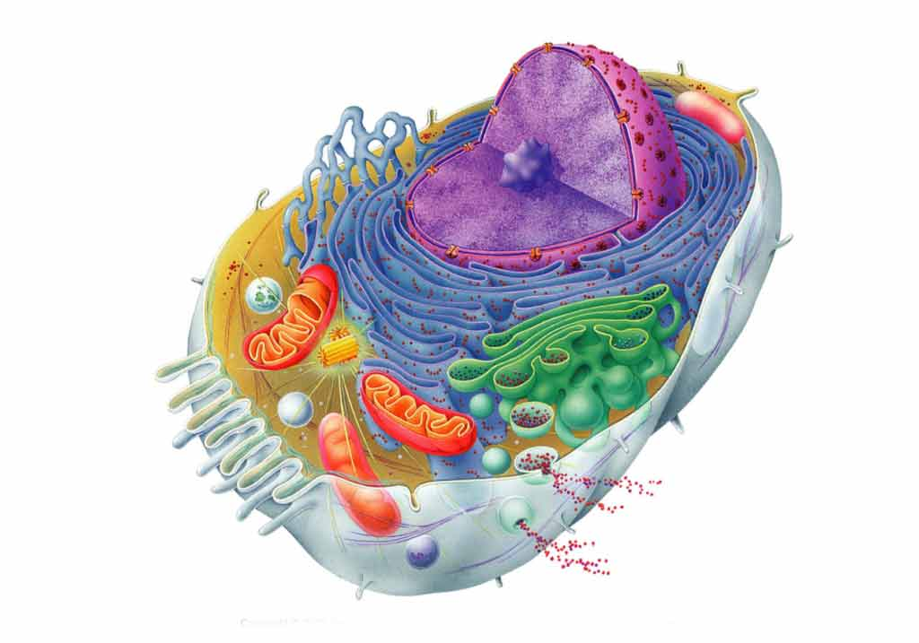 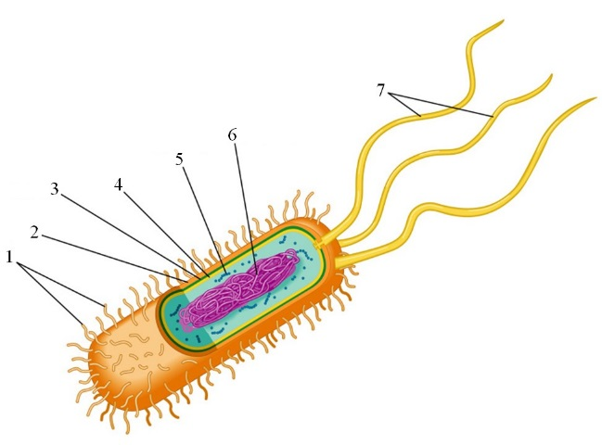

**B**

**A**

**A1: List 4-5 ways that cells A & B are different.**

**B: Watch the following video/read the following excerpt and answer these questions #1-11 (COMPLETE SENTENCES) while you are watching.**

<http://www.youtube.com/watch?v=yWy4o_UfZ4A>

All living organisms can be sorted into one of two groups depending on the fundamental structure of their cells. These two groups are the **prokaryotes** and the **eukaryotes**.

Prokaryotes are organisms made up of cells that lack a cell nucleus or any membrane-bound organelles. This means the genetic material, DNA, in prokaryotes is not bound within a nucleus. Additionally, the DNA is less structured in prokaryotes than in eukaryotes. In prokaryotes, DNA is a single loop. In Eukaryotes, DNA is organized into chromosomes. Most prokaryotes are made up of just a single cell (unicellular) but there are a few that are made of collections of cells (colonies).

Eukaryotes are organisms made up of cells that possess a membrane-bound nucleus (that holds genetic material) as well as membrane-bound organelles. Genetic material in eukaryotes is contained within a nucleus within the cell and DNA is organized into chromosomes. Eukaryotic organisms may be multicellular or unicellular. Eukaryotes can be further divided into plant and animal cells. Plant cells and animal cells differ slightly in that plant cells have a cell wall and chloroplasts while animal cells do not.

1. What are the two types of cells?
2. What are examples of prokaryotes?
3. Which type of cell has a membrane bound nucleus? Which type does not?
4. Which type of cell has membrane bound organelles? Which type does not?
5. What important hereditary component do both prokaryotes and eukaryotes share?
6. In what form is DNA found in prokaryotes?
7. Where can DNA be found in eukaryotes? How is it packaged?
8. Both types of cells contain ribosomes. What is the function of ribosomes?
9. Create a chart like the one found below to compare the two types of cells.

|  |  |  |
| --- | --- | --- |
|  | **Prokaryotes** | **Eukaryotes** |
| **Contains a nucleus** |  |  |
| **Contains organelles** |  |  |
| **Contains DNA** |  |  |
| **Contain ribosomes** |  |  |
| **Examples** |  |  |

1. An antibiotic is a type of medicine that is used to treat certain diseases that are caused by bacteria. Doctor Inge uses Antibiotic A to treat athlete’s foot, a condition caused by a fungus. Three days later, the patient comes back and reports no change in their condition. What can we conclude about fungi? Why doesn’t the antibiotic work on the fungus that causes athlete’s foot?
2. **Critical Thinking**
   1. Pharmaceutical companies create medicines to treat human diseases. Why must these companies consider the differences between prokaryotic and eukaryotic cells? (Hint: Many diseases are caused by bacteria).

**Introduction to Cells Worksheet ANSWERS**

**\*\*On a separate sheet of paper, write down “Part I” with it numbered 1-10 below it, Part II for your timeline and “Part III” with it numbered 1-11 below. Do this as you go, not before.**

Part I: Ted ED Video

**Answer the following questions in COMPLETE SENTENCES while watching the Ted ED video on cell theory.**

[**http://ed.ted.com/lessons/the-wacky-history-of-cell-theory**](http://ed.ted.com/lessons/the-wacky-history-of-cell-theory)

1. What are the three parts of the cell theory?

All living things are made of cells

Cells are the basic unit of life

All cells come from pre-existing cells

1. What hot commodity did Zacharias Jansen invent which greatly contributed to science? Compound Microscope
2. What did Anton van Leeuwenhoek discover by looking at his dental scrapings? What name did he give his discoveries? Bacteria. Called them animalcules.
3. What did Robert Hooke look at under his microscope? Cork.
4. What term did Hooke coin? How did he come up with this term? “Cells.” He thought the cells in cork looked like the empty cells in the monastery.
5. What did Matthias Schleiden study? What conclusion did Schleiden come to after years of study? Plants. All plants are made of cells.
6. What conclusion did Theodor Schwann come to after years of study? All animals are made of cells.
7. Which two scientists were the first to work on the cell theory? Schleiden and Schwann.
8. What was Schleiden’s opinion on how cells were created? He believed they were spontaneously generated (crystallized into existence).
9. How did Rudolph Virchow contribute to the cell theory? Discovered that all cells must come from preexisting cells.

Part II: Cell Theory Timeline

**Use the following website to create a timeline on a separate sheet of paper for the history of the cell theory. It should look like the example on the board.**

Timeline must have:

1. Date
2. Scientist’s name
3. Discovery of each scientist

<http://utahscience.oremjr.alpine.k12.ut.us/sciber00/7th/cells/sciber/cellhist.htm>

Part III: Types of Cells

* Observe the pictures of cells on the following page. Answer A1.
* Watch the video and read the excerpt. Answer #B1-11.

 

**B**

**A**

**A1: List 4-5 ways that cells A & B are different.**

**B: Watch the following video/read the following excerpt and answer these questions #1-11 (COMPLETE SENTENCES) while you are watching.**

<http://www.youtube.com/watch?v=yWy4o_UfZ4A>

All living organisms can be sorted into one of two groups depending on the fundamental structure of their cells. These two groups are the **prokaryotes** and the **eukaryotes**.

Prokaryotes are organisms made up of cells that lack a cell nucleus or any membrane-bound organelles. This means the genetic material, DNA, in prokaryotes is not bound within a nucleus. Additionally, the DNA is less structured in prokaryotes than in eukaryotes. In prokaryotes, DNA is a single loop. In Eukaryotes, DNA is organized into chromosomes. Most prokaryotes are made up of just a single cell (unicellular) but there are a few that are made of collections of cells (colonies).

Eukaryotes are organisms made up of cells that possess a membrane-bound nucleus (that holds genetic material) as well as membrane-bound organelles. Genetic material in eukaryotes is contained within a nucleus within the cell and DNA is organized into chromosomes. Eukaryotic organisms may be multicellular or unicellular. Eukaryotes can be further divided into plant and animal cells. Plant cells and animal cells differ slightly in that plant cells have a cell wall and chloroplasts while animal cells do not.

1. What are the two types of cells? Prokaryotes and eukaryotes.
2. What are examples of prokaryotes? Bacteria.
3. Which type of cell has a membrane bound nucleus? Which type does not? Eukaryotes have a membrane bound nucleus, prokaryotes don’t.
4. Which type of cell has membrane bound organelles? Which type does not? Eukaryotes HAVE organelles, prokaryotes don’t.
5. What important hereditary component do both prokaryotes and eukaryotes share? DNA.
6. In what form is DNA found in prokaryotes? In the nucleoid region (loose coils).
7. Where can DNA be found in eukaryotes? How is it packaged? IN the nucleus in chromosomes.
8. Both types of cells contain ribosomes. What is the function of ribosomes? To create proteins.
9. Create a chart like the one found below to compare the two types of cells.

|  |  |  |
| --- | --- | --- |
|  | **Prokaryotes** | **Eukaryotes** |
| **Contains a nucleus** | NO | YES |
| **Contains organelles** | NO | YES |
| **Contains DNA** | YES | YES |
| **Contain ribosomes** | YES | YES |
| **Examples** | Bacteria | Protists, plants, animals, humans. |

1. An antibiotic is a type of medicine that is used to treat certain diseases that are caused by bacteria. Doctor Inge uses Antibiotic A to treat athlete’s foot, a condition caused by a fungus. Three days later, the patient comes back and reports no change in their condition. What can we conclude about fungi? Why doesn’t the antibiotic work on the fungus that causes athlete’s foot?

Bacteria are prokaryotes. The medicine targets prokaryotes. If the medicine does not work on fungus, we can conclude that fungus is a eukaryote. The medicine will not work on fungus BECAUSE it only works on prokaryotes.

1. **Critical Thinking**
   1. Pharmaceutical companies create medicines to treat human diseases. Why must these companies consider the differences between prokaryotic and eukaryotic cells? (Hint: Many diseases are caused by bacteria).

The medicines must only target prokaryotic structures because humans are eukaryotic. If the medicine destroys/kills structures that both eukaryotes and prokaryotes have, then humans will be harmed as well as the prokaryotes.