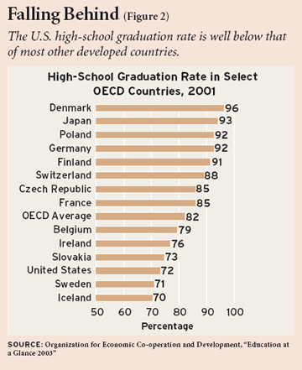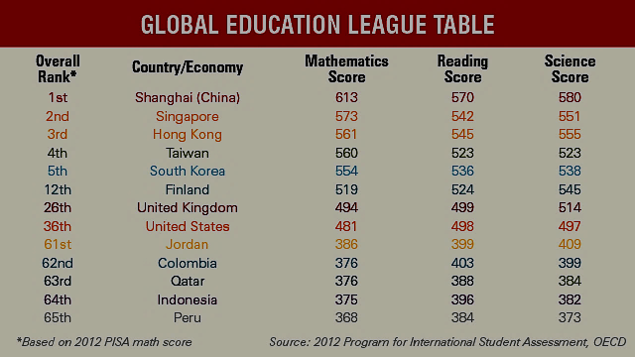**P4** | APUSH | Ms. Wiley | Education & Reform, D___ Name:

*We’ll begin by looking at some current educational issues and then use that conversation to frame our analysis of education in America up to 1840ish.*

1. Does America have a strong public education system today? Why or why not? What do you think makes an education system (or school) “strong”?
2. If you could make two changes to the public school system today what would they be and why? Why might some oppose those measures?
3. Record your reactions to the clips below:

|  |  |  |
| --- | --- | --- |
| *2 Million Minutes* | *Finnish Education— Equal Opportunity for All* | *Philadelphia Schools Crippled by  Budget Crisis* |
|  |  |  |

**The Rise of Public Education in Early America**

As George Washington ended his term as the first president of the United States, he left with a few parting words. Washington’s Farewell Address of 1796 delineated many of the recommendations Washington had for the future of his country; much of the text emphasized that the nation should avoid foreign entanglements and political parties. A lesser known suggestion was a public education system. Washington instructed American leaders to “promote… institutions for the general diffusion of knowledge. In proportion as the structure of a government gives force to public opinion, it is essential that public opinion should be enlightened.” Washington saw the importance of educating the American public as a means to grow the country economically, but also to create a well-informed populace to participate in America’s newly founded republic. Washington never lived to see the formation of such an education system, as he died a few years after leaving office in 1799. Even so, Washington’s remarks on education were not lost on American policymakers. The nineteenth century witnessed a drastic transformation in attitudes towards public education in the United States.

***Public Education in the American Colonies***

Education in the American colonies began as a religious endeavor. In the seventeenth century, New England’s Puritan settlers stressed that everyone learn how to read the Bible. Puritan leaders began enforcing this through the Massachusetts Bay School Law of 1642. This directive removed education responsibilities from the hands of the clergy and required that parents teach their children how to read and write. This method, however, did not work effectively and by the mid-seventeenth century the Puritan community began implementing new laws such as the Old Deluder Act of 1647. This decree, “ordered that every township in this jurisdiction, after the Lord hath increased them to fifty households shall forthwith appoint one within their town to teach all such children as shall resort to him to write and read.” In other words, each town was forced to fund and operate a local school. Unfortunately, the schools tended to focus on producing an educated elite class and not on educating the entire public. In colonial America, public education was first and foremost a means to educate an elitist class of future political and business leaders. Education for commoners was largely left to families and churches.

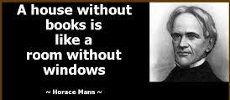

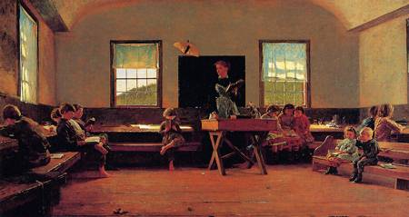

Education across the colonies differed significantly. In ethnically and religiously homogeneous colonies, public education was far more widespread than it was in colonies with greater social diversity. Colonies like Massachusetts, whose citizens were largely British-born or descended from Puritans, were more apt to have state-run public schools. Other colonies, such as New York or Pennsylvania, where there was an assortment of religious groups with Quakers, Lutherans, Catholics, ancestral diversity with large German populations, and greater physical distances between communities bred a greater focus on localized education. Local entities, such as churches and parent groups, seized control of education because in a territory with a wide variety of cultures and religions it was important that each sect of society was able to educate its own in a way it saw fit. Since most middle American colonies were similar to Pennsylvania and New York, the foundations of American public education were strongly rooted in locally run schools and not statewide education programs by the time America gained independence. Meanwhile, Southern education initiatives were few and far between, with the aristocratic elite hiring private tutors or sending children to England (or elsewhere in Europe) for a formal education.

1. What were the differences in education between New England colonies, Middle colonies, and Southern (Chesapeake) colonies? What may have created these differences (think about the difference in makeup of colonists and motives for settlement, P2)?

|  |  |  |
| --- | --- | --- |
| New England Colonies | Middle Colonies | Southern Colonies |
|  |  |  |

***After the Revolutionary War***

The years following America’s independence from Britain in 1783 did little to change the American public education system. Education remained a responsibility of individual families and local communities, not a duty of state or federal governments. Congress issued the Land Ordinance of 1785, ordering each township established in the new western territories to have space set aside for a public school: “There shall be reserved [a] lot… of every township, for the maintenance of public schools.” Congress also implemented the Northwest Ordinance of 1787, stating that; “religion, morality, and knowledge, being necessary to good government and the happiness of mankind, schools and the means of education shall forever be encouraged.” Education remained a primarily local obligation, however, as neither ordinance was put fully into effect.

Despite Congress’ failure to institute meaningful education reform following the Revolutionary War, a few American leaders began voicing support for a more extensive and structured public education system. One of the loudest voices was Thomas Jefferson. Jefferson’s greatest contribution to educational reform arrived with his Bill for the More General Diffusion of Knowledge. Arguing that a better-educated populace would result in a freer and happier American public, the bill called for a widespread system of public education. He asserted that the American government had the responsibility to foster the education of a meritocracy in which all citizens could compete. During the late eighteenth century, however, resistance to government-funded education was strong. In both 1778 and 1780, Jefferson failed to get the bill to pass through Congress.

To the dismay of Jefferson, it would take until the 1840s for a substantial public education system to emerge—in just *some* states. The Revolutionary War, though, did turn greater attention towards the education of women. Previously, the education of women was limited to elementary reading and writing along with the development of homemaking skills. Towards the end of the eighteenth century, the first private female academies started opening their doors. These institutions supported the new American vision that mothers were responsible to mold the moral and intellectual character of their children and would thus need to be educated well enough to do so (Republican Motherhood).

1. Should the Revolutionary War (1776-1783) be used as a turning point when it comes to education in America? Why or why not? Do not use women as the sole focus of your response, since this was previously discussed in Period 3.

***The Nineteenth Century and the Common School Movement***

***T***hough it lacked an official public education system, the United States had the world’s highest literacy rate in the early nineteenth century. Informal means of education—such as apprenticeships, charity schools, and church schools—helped fill in the gaps created by the absence of public schools. Private academies only admitted those who could afford to attend them and even some “free” schools offered by local communities charged tuition. Moreover, many schools required prospective students to know how to read and write. This kept children whose parents did not educate them at home out of the schooling system.

Students able to attend early nineteenth century schools faced many challenges of their own. Children under the age of five were often times mixed in with adults in their twenties. Additionally, classrooms were frequently overcrowded, housing as many as eighty students at a time. Because of the overcrowding, already scarce textbooks and learning materials had to be spread even more thinly amongst students. As a result, class time amounted to a tedious recitation of facts and instructor struggled to devote individual attention to students.

It was not until the 1840s that a structured system of public education started to emerge in the United States. Reformers built common schools on a state-by-state basis. Education pioneers promoted educational reform as a means to enhance the economic opportunities for all Americans and to create a shared bond amongst the citizens of a very diverse population. Common school supporters sought to found completely free elementary schools available to all American children. For this reason, the nineteenth century is often referred to as the “Common School Period” because American education transitioned from an entirely private endeavor to *some* public availability.

Note: Recent scholarship has argued that public schooling arose in response to an influx of immigrants (particularly Irish and German) who had different religions or cultures, its primary focus to establish social order and mainstream vast numbers of immigrant children into a common school setting. It was a mistrust of parents that was *common* during the birth of public schools. As an 1851 article in The Massachusetts Teacher reported: “In too many instances the parents are unfit guardians of their own children … the children must be gathered up and forced into school”.

1. What filled the gap created by an absence of public schools in the 19th century?
2. What were some of the problems associated with schools in the 19th century?

*[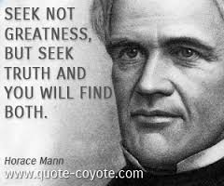](http://www.google.com/url?sa=i&rct=j&q=horace+mann&source=images&cd=&cad=rja&uact=8&ved=0CAcQjRw&url=http://www.quote-coyote.com/quotes/authors/m/horace-mann/&ei=f7t_VOSDE8argwSxnoGQDA&bvm=bv.80642063,d.aWw&psig=AFQjCNHcEPPQmtpqWySElNAyUIg7yjwQNA&ust=1417743572767268)Horace Mann’s Influence on American Education*

Horace Mann has been called the father of American “common,” or public, education. Indeed, he was a champion of the non-privileged classes, a man who worked tirelessly to overcome the injustices in our 19th century educational system. Associating with anti-slavery and reform leaders, Mann came to his zealous advocacy of public education from a career as a successful lawyer and legislator.

Although Massachusetts Colony had passed several laws and resolutions in the 17th century that made its towns responsible for providing education for all children within their boundaries, in fact there was little financial support or enforcement of universal schooling. By the early 19th century, when Horace Mann was growing up, public schools offered the bare minimum of education, often only to those families that could pay fees. Yearly school terms were rarely more than a few weeks long; absenteeism was extremely high; there were no common textbooks; buildings were inadequate and unequipped; and teachers were usually young, inexperienced, ignorant, and untrained. Wealthy families had long opted for private tutors or elite academies, and poorer families, such as Mann’s, might well decide that they could afford to educate only one of several children. As the growth of manufacturing split the populace between laborers and entrepreneurs, differing opportunities for education made class distinctions even more pronounced. The common, or public, schools came to be regarded as charity institutions for the children of small farmers and laborers. There was little support for local or state funding through taxes.   
  
In 1837 Massachusetts received a two-million-dollar windfall from the federal government—payment for services of state militias during the War of 1812. Mann, by then president of the state senate and a friend of the governor, was persuaded to support a bill that allocated part of this money to establish a state board of education, defined largely as an agency to gather data about MA schools and to disseminate information about new and useful innovations in teaching. The Board, empowered to appoint a secretary to carry out its mission, turned to Horace Mann. Each year, as mandated by law, he wrote a report to the Board, discussing the current state of the schools and their future needs. These *Annual Reports*, along with the *Common School Journal*, which Mann founded, presented important questions of policy and practice as well as statistical data.

Throughout his career as an educator, Mann had to defend his conviction that state-organized education could teach positive moral and civic values without favoring any particular doctrine. One of his first initiatives as secretary had been to make available in every school a core library of about 40 books that could be loaned to students and their families. Mann had educated himself sufficiently to enter Brown University at the sophomore level largely by reading through the holdings of the local library in the town of Franklin. These books had been donated by Benjamin Franklin when the town honored him by its choice of name.   
  
From the outset, the principle of statewide public education sparked controversies that continued throughout Mann’s tenure in office. Struck by the large number of Irish immigrant children living in squatters’ camps beside the railroad lines on which their fathers worked, he pushed for mandatory education laws that would require towns and districts to provide schooling for all children, whether permanent residents or not. He also wanted parents held responsible for their children’s attendance. But the very immigrant groups the laws were designed to help were among his greatest opponents. Without education themselves, the laborers saw little value in having their children attend school when they could work in factories and add to the family income. In fact, they regarded truant officers as “kidnappers.” Property owners whose taxes were required to support schools for immigrant children were equally opposed due to nativist sentiment, and the newly powerful Jacksonian Democrats, who gained the governorship of Massachusetts in 1839 with the backing of labor groups, set out to abolish the State Board of Education and all its activities.   
  
Along with insisting that districts provide schools that met a minimum standard of quality and that children be required to attend them, Mann is best known for founding the first state-funded institutions for training teachers in the country. The normal schools and the educated corps of teachers they produced increased the professionalism and the financial status of teachers, especially women, and promulgated the idea that teaching was a skill requiring careful development. “Teaching,” he wrote in the *First Annual Report*, “is the most difficult of all arts and the profoundest of all sciences.” Mann’s conviction that appropriate teaching methods were the key to student learning led him to lengthy research and study of contemporary theories of psychology and cognition.

|  |  |  |  |
| --- | --- | --- | --- |
| **Average Monthly Salaries, Including Board, of Teachers in 1847**   |  |  |  | | --- | --- | --- | | State Connecticut  Indiana Massachusetts Michigan New Hampshire New York Ohio Pennsylvania  Vermont | Men $16.00    12.00    25.44    12.71   13.50   14.96   15.42   17.02   12.00 | Women  $6.50     6.00  11.38    5.36    5.65    6.69    8.73  10.09     4.75 |   In his *Eleventh Annual Report* of 1847, Horace Mann published these average teaching salaries. He wrote that if these salaries are “compared with what is paid to cashiers of banks, to secretaries of insurance-factories, to custom-house officers, Navy agents, and so forth, it will then be seen what pecuniary temptations there are on every side, drawing enterprising and talented young men from the ranks of the teacher’s profession.” |

Although it was difficult at times, Mann succeeded in persuading a majority of his contemporaries that free schools with trained teachers could inculcate desirable social values and simultaneously provide a practical education leading to prosperous and constructive citizenship. Today, education reformers argue that the possibility of achieving consensus about the content and promise of education is a fading dream. What seems to have been “lost” amid the standardized test culture since Mann’s time is his faith that public education, properly supported and provided, could be the means of creating a better society. . . .

1. What were Horace Mann’s key beliefs regarding education and the role of the government in education?
2. Why did public funding for education face a great deal of opposition in the 19th century?

**HORACE MANN ON EDUCATION AND NATIONAL WELFARE**1848 (Twelfth Annual Report of Horace Mann as Secretary of Massachusetts State Board of Education)

Our ambition as a State should seek the solution of such problems as these: To what extent can competence displace pauperism? How nearly can we free ourselves from the low-minded and the vicious, not by their expatriation, but by their elevation? To what extent can the resources and powers of Nature be converted into human welfare, the peaceful arts of life be advanced, and the vast treasures of human talent and genius be developed? How much of suffering, in all its forms, can be relieved? or, what is better than relief, how much can be prevented? Cannot the classes of crimes be lessened, and the number of criminals in each class be diminished? . . .

[Discussing Massachusetts:] By its industrial condition, and its business operations, it is exposed, far beyond any other State in the Union, to the fatal extremes of overgrown wealth and desperate poverty. . . . Now surely nothing but universal education can counterwork this tendency to the domination of capital and the servility of labor. If one class possesses all the wealth and the education, while the residue of society is ignorant and poor, it matters not by what name the relation between them may be called: the latter, in fact and in truth, will be the servile dependents and subjects of the former. Property and labor in different classes are essentially antagonistic; but property and labor in the same class are essentially fraternal. . . .

Education then, beyond all other devices of human origin, is a great equalizer of the conditions of men,—the balance wheel of the social machinery. [I]t gives each man the independence and the means by which he can resist the selfishness of other men. It does better than to disarm the poor of their hostility toward the rich: it prevents being poor. . . . Education prevents both the revenge and the madness. On the other hand, a fellow-feeling for one's class or caste is the common instinct of hearts . . . . The spread of education, by enlarging the cultivated class or caste, will open a wider area over which the social feelings will expand; and, if this education should be universal and complete, it would do more than all things else to obliterate factitious distinctions in society. . . .

For the creation of wealth, then,—for the existence of a wealthy people and a wealthy nation,—intelligence is the grand condition. The number of improvers will increase as the intellectual constituency, if I may so call it, increases. That political economy, therefore, which busies itself about capital and labor, supply and demand, interests and rents, favorable and unfavorable balances of trade, but leaves out of account the elements of a wide-spread mental development, is naught but stupendous folly. For mere delving, an ignorant man is but little better than a swine, whom he so much resembles in his appetites, and surpasses in his power of mischief. . . .

1. Which two quotes stood out to you the most? Bracket them and label them #1 and #2. Explain your selections below.

1. Is Mann’s writing anti-capitalistic? Why or why not?
2. How does Horace Mann and the common school movement fit in this era (1800-1840ish)? Are you surprised that this movement emerged during this time? Are you surprised Mann was from MA? Why or why not?