Protein Synthesis Simulation Activity
Name: ________________________ Date: _______

Part 1: Introduction
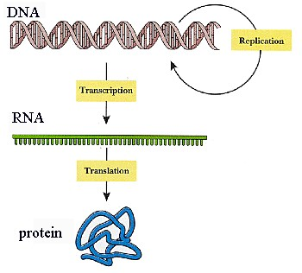
DNA is a very long, thin molecule located in the nucleus. The DNA in one chromosome has 10s of millions of base pairs and hundreds or thousands of genes. Yet an individual cell will only use a small portion of those genes in its lifetime. Imagine a mechanic who spends a lifetime fixing nothing but cars, but he or she is required nonetheless to carry around an entire library of repair manuals for everything from kitchen sinks to washing machines to light fixtures to computers and so on – all information the mechanic will never be able to use because s/he’s busy fixing cars.
Another peculiar thing about DNA is that it is located inside the nucleus, and pretty much stays inside the nucleus, yet the proteins that DNA helps to make are produced OUTSIDE of the nucleus. So how does the cell solve this problem? It sends a “messenger” from the nucleus to the ribosomes in the cytoplasm.
In a process called transcription, the DNA code is transcribed (copied) into mRNA, following rules similar to DNA replication we saw earlier (see below).
mRNA moves out of the nucleus into the cytoplasm where it links up with ribosomes and begins churning out proteins.
Recall that DNA consists of a sugar-phosphate backbone with a nitrogenous base. There are 4 different bases in DNA abbreviated with the letters A,T,C, & G. The code contained in DNA derives from these 4 bases. We can think of them as letters in an alphabet that will spell different words. In a real language, words can be anywhere from 1 letter long (a, I) to an upper limit of 10-15 letters for functional, non-compound words.
In DNA code, a “word” is always 3 letters long and is called a “codon.” Consider the following DNA segment:
A
G
T
C
C
A
A
A
T
C

T
C
A
G
G
T
T
T
A
G

“ATC” is a codon. “GTC” is a codon. “CAA” is a codon. Etc.

In transcription, the DNA code is transcribed (copied) into RNA code, following rules similar to DNA replication we saw earlier EXCEPT that:

DNA RNA
1. Transcribe the following DNA sequence into mRNA. Draw a line separating each codon:
DNA template = A T C G T C C A A A ….
mRNA = ______________________________________

Matches with
A……………. U
T……………. A
C……………. G
G……………. C

Each mRNA codon corresponds to an amino acid that is transported to the RNA/ribosome complex by another special nucleic acid called tRNA. “T” stands for transfer. The ribosome essentially “reads” the RNA code and facilitates the linking of appropriate amino acids to make proteins. Summary diagram:
2. Transcribe the following DNA sequence into mRNA. Draw a line separating each codon:
DNA template= T A G C A G G T T T ….
mRNA= _________________________________

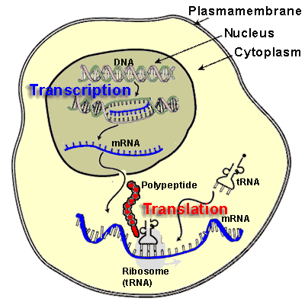
DNA (in nucleus) transcribed to mRNA

mRNA leaves nucleus

mRNA to cytoplasm

mRNA hooks up with ribosomes.

Ribosomes scroll through mRNA

tRNA delivers amino acids to mRNA/ribosome complex

Enzymes link amino acids together to form a protein

Amino Acid
Chain

Part 2: Questions
1. There are 64 possible codons using 4 letters (AUCG) with 3 letters per codon in any order. However, there are only 20 amino acids, and each codon “codes” for one amino acid – so what does this mean?

___________________________________________________________________________

The table below shows which amino acid corresponds with which codons.
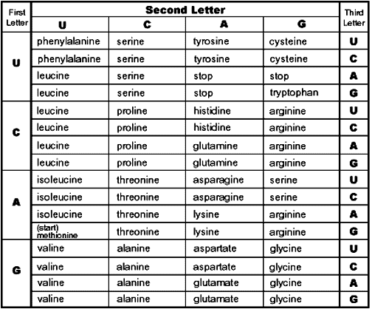
2. What does UAC code for?
_________________________

3. CAG? _________________

4. AGG?_________________

5. GAU? _________________

6. UUU? _________________

7. List all the codons for Valine:

________________________

8. Stop? _________________

9. Methionine is a “Start” signal. What is its codon? ____________

Each amino acid is matched with one or more 3-letter “words.” The words are analogous to an amino acid. When the words are put together they make a sentence. The sentence is analogous to a protein. So, let’s break the following code.

10. Given the following DNA code, how would this segment be transcribed into mRNA?

DNA template = T A C C C G A T A C T C C C T T C A A T T

mRNA = ________________________________________________

11. Based on your mRNA sequence form #10, list the amino acids coded for in that sequence. (Hint→ First, draw brackets under your mRNA strand at every three letters, then use these letters to look on the chart for the amino acid they call for.)

___________________________________________________________________________

12. What is the silly little sentence that this codes for (see p. 4)?
___________________________________________________________________________

Amino Acid – English word Table
Methionine  START | Glycine  THE | Alanine  SAD | Valine  RAT | Isoleucine  MET
Phenylalanine  RAN | Histidine  OLD | Tryptophan  FOE | Proline  SLY | Serine  CAT
Threonine  WHO | Glutamate  SAW | Cysteine  MAD | Arginine  ATE | Tyrosine  DOG
Asparagine  AND | Glutamine  HIS | Aspartate  FOR | Leucine  DAY | Lysine  BIG
STOP
.

In the remaining space, create your own messages and, working backwards, determine what the DNA sequence would be:

Your message: ______________________________________________________________

Amino acid: ______________________________________________________________

mRNA sequence: ______________________________________________________________

DNA Sequence: ______________________________________________________________

Your message: ______________________________________________________________

Amino acid: ______________________________________________________________

mRNA sequence: ______________________________________________________________

DNA Sequence: ______________________________________________________________

