The Confederate bombardment of Fort Sumter in Charleston, South Carolina, ended months of confusion. The nation was at war. The time had come to choose sides. For most whites in the South, the choice was clear. Early in 1861, representatives from six of the seven states that had seceded from the Union met to form a new nation called the Confederate States of America. Southerners believed that just as the states had once voluntarily joined the Union, they could voluntarily leave it now. The men who fought for the South were proud defenders of Southern independence.

For many Northerners, the choice was just as clear. “There can be no neutrals in this war,” declared Senator Stephen Douglas after the attack of Fort Sumter, *“only patriots—or traitors.”* Most Northerners viewed the secession of Southern states as a traitorous act of rebellion against the United States. They marched off to war eager to defend what they saw as their union, their constitution, and their flag.

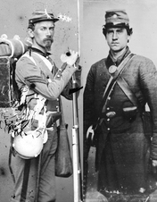

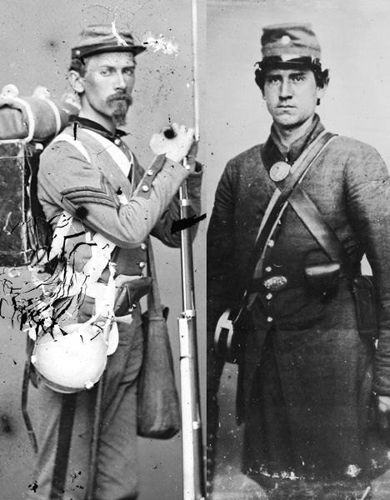

Library of Congress

The Civil War divided Americans into two opposing nations. Union soldiers (left) fought fellow Americans and Confederate soldiers (right).

Choosing sides was harder for the eight slave states located between the Confederacy and the free states. Four of these so-called border states—Virginia, Arkansas, Tennessee, and North Carolina— joined the Confederacy. The western counties of Virginia, however, remained loyal to the Union. Rather than fight for the South, they broke away to form a new state called West Virginia. The other four border states—Delaware, Maryland, Kentucky, and Missouri—remained in the Union, although many of their citizens fought for the South.

As Americans took sides, they began to see why a civil war—a conflict between two groups of citizens in one country—is the most painful kind of war. This conflict divided not only states, but also families and friends. In this chapter, you will learn how this “brothers’ war” turned into the most destructive of all American wars. As you read, put yourself in the shoes of the soldiers and civilians who were part of this long and tragic struggle.

President Abraham Lincoln’s response to the attack on Fort Sumter was quick and clear. He called for 75,000 volunteers to come forward to preserve the Union. At the same time, Jefferson Davis, the newly elected president of the **Confederacy[Confederacy: another name for the Confederate States of America, made up of the 11 states that seceded from the Union]** , called for volunteers to defend the South. For the first time, Americans were fighting a **civil war [civil war: a war between opposing groups of citizens from the same country]** .

**Strengths and Weaknesses of the North** The North began the war with impressive strengths. Its population was about 22 million, compared to the South’s 9 million. The North was both richer and more **technologically [technologically: resulting from improvements in knowledge, equipment, or methods]** advanced than the South. About 90 percent of the nation’s manufacturing, and most of its banks, were in the North.

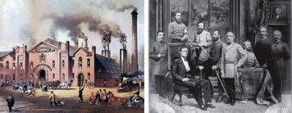

Click to read caption

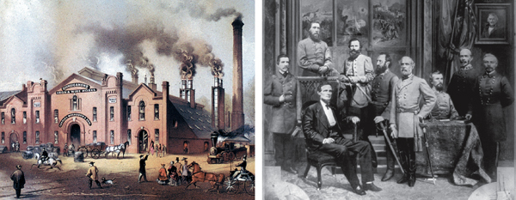

The Granger Collection,New York/Library of Congress

The North and the South had different strengths at the beginning of the war. The North had far more factories and railroad lines (left). The South had better military leadership (right).

The North had geographic advantages, too. It had more farms than the South to provide food for troops. Its land contained most of the country’s iron, coal, copper, and gold. The North controlled the seas, and its 21,000 miles of railroad track allowed troops and supplies to be transported wherever they were needed.

The North’s greatest weakness was its military leadership. At the start of the war, about one-third of the nation’s military officers resigned and returned to their homes in the South. During much of the war, Lincoln searched for effective generals who could lead the Union to victory.

**Strengths and Weaknesses of the South** In contrast to the North, the South’s great strength was its military leadership. Most of America’s best military officers were Southerners who chose to fight for the Confederacy. This was not an easy decision for many of them. Colonel Robert E. Lee, for example, was not a supporter of either slavery or secession. But he decided that he could not fight against his native Virginia. Lee resigned from the U.S. Army to become commander in chief of the Confederate forces.

The South had geographic advantages as well. To win the war, the North would have to invade and conquer the South. The sheer size of the South made this a daunting task. The South, in contrast, could win simply by defending its territory until Northerners grew tired of fighting.

The South did have an important geographic disadvantage. If the Union could control the Mississippi River, it could split the Confederacy in two.

The South’s main weaknesses were its economy and its transportation systems. The region’s agriculturally based economy could not support a long war. It had few factories to produce guns and other military supplies. The Confederacy also faced serious transportation problems. The South lacked the railroads needed to haul troops or supplies over long distances.

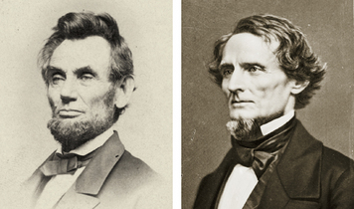

Click to read caption

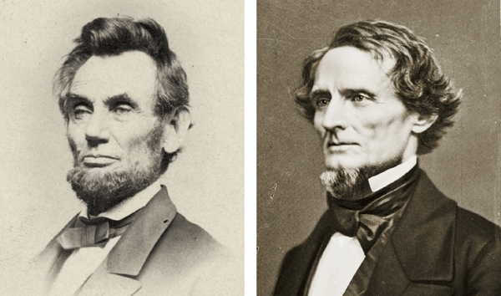

Library of Congress

Abraham Lincoln (left) and Jefferson Davis (right) at the start of the Civil War.

**Abraham Lincoln versus Jefferson Davis** The North’s greatest advantage was its newly elected president, Abraham Lincoln. Through even the darkest days of the war, Lincoln never wavered from his belief that the Union was **perpetual [perpetual: continuing forever]** —never to be broken. Throughout his presidency, Lincoln related the preservation of the Union to the ideals of the American Revolution. In his first inaugural address, he said that the Union was begun by the American Revolution, “matured and continued” by the Declaration of Independence, and affirmed by the Constitution.

At the time of the secession **crisis [crisis: a dangerous moment with a high chance of an unwanted result]** , Jefferson Davis was a U.S. senator from Mississippi. A firm believer in states’ rights, he resigned his seat in the Senate when Mississippi left the Union. Like Lincoln, Davis often spoke of the American Revolution. When Southerners formed their own government, Davis said in his inaugural address, they “merely **asserted [asserted: to state firmly]** a right which the Declaration of Independence of 1776 had defined to be inalienable.” He believed the South was fighting for the same freedom cherished by the nation’s founders.

1. The states that seceeded from the Union were offically called - ___________________________________________________.
2. Who was the new president of the seceeded states?
3. Explain the strategies for victory for the North and South:

|  |  |
| --- | --- |
| North (called: ___________________) | South ***\*\*\*\**** |
|  |  |
|  |  |
|  |  |