Name: _________________________________ Date: ______________________

*City of Ember*

by Jeanne DuPrau

Chapters 1-4

Answer the following questions in complete sentences.

1. How long were people supposed to stay in the city of Ember and how long have they been there?

________________________________________________________________________________________________________________________________________________



1. What is the most terrible thing that could happen to the people of Ember?

________________________________________________________________________________________________________________________________________________

1. How long does each person keep his or her first job and what age do they get their job?

________________________________________________________________________________________________________________________________________________

1. Describe the pipework’s laborer job.

________________________________________________________________________________________________________________________________________________

1. What happened between Doon and Lina that broke up their friendship?

________________________________________________________________________________________________________________________________________________

1. Why do Lina and Poppy live with Granny?

________________________________________________________________________________________________________________________________________________

1. As Lina was waiting to deliver a message to the mayor, what did she do that caused a commotion? ________________________________________________________________________________________________________________________________________________

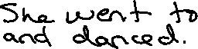

1. Where did Doon go during lunch on his first day at the pipeworks?

________________________________________________________________________________________________________________________________________________



1. Why did Doon think disaster was right around the corner? ________________________________________________________________________________________________________________________________________________



1. Why did Doon head for home instead of talking to Lina when he saw her on the roof? ________________________________________________________________________________________________________________________________________________

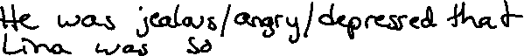

1. What advice did Doon’s father give him? ________________________________________________________________________________________________________________________________________________



1. Doon had always been fascinated by what type of creature? ________________________________________________________________________



1. Why was Granny tearing apart the couch when Lina came home? ________________________________________________________________________________________________________________________________________________



1. Describe a trash sifters job. Why was this job created? ________________________________________________________________________________________________________________________________________________

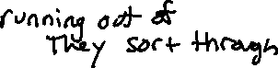

1. What happened to the potatoes at the greenhouse? ________________________________________________________________________________________________________________________________________________



1. Where had the man come from and what had he been looking for (page 62-65) ________________________________________________________________________________________________________________________________________________

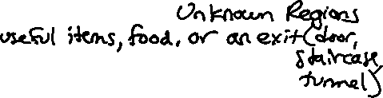

Chapters 5-10

1. Why did Lina like having Mrs. Murdo around? ________________________________________________________________________________________________________________________________________________

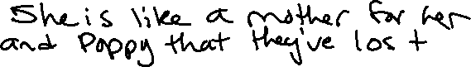

1. Who ran the store where Lina bought the colored pencils? Why do we know this person? ________________________________________________________________________________________________________________________________________________



1. Why was Lina looking for Poppy after she bought the colored pencils? ________________________________________________________________________________________________________________________________________________

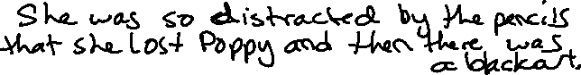

1. Who was Poppy found with after the blackout? _________________________________



1. How did Lina feel about her colored pencils after she got home? ________________________________________________________________________________________________________________________________________________

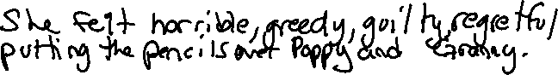

1. Why was the most recent blackout so significant? ________________________________________________________________________________________________________________________________________________



1. According to mayor, what was the worst possible thing people could do? ________________________________________________________________________



1. What is the “trouble with anger” according to Doon’s father? ________________________________________________________________________________________________________________________________________________



1. When Lina came home to the apartment, why did she trip and fall? ________________________________________________________________________________________________________________________________________________



1. Describe the box Lina took from Poppy? ________________________________________________________________________________________________________________________________________________



1. Why did Lina think the piece of paper came from the Builders? ________________________________________________________________________________________________________________________________________________



1. Who did Lina ask to first look at the writing she found? ___________________________



1. What do the Believers think is going to happen? ________________________________________________________________________________________________________________________________________________



1. On Lina’s day off, who did she ask for help? How did it go? ________________________________________________________________________________________________________________________________________________



1. What do *ip* and *ork* stand for? Who does Lina immediately think of to help her? ________________________________________________________________________________________________________________________________________________



1. What did Doon hope to find when he went to the library? ________________________________________________________________________________________________________________________________________________



1. What do Lina and Doon believe the door in the storage rooms could lead to? ________________________________________________________________________________________________________________________________________________



1. Why did Lina and Doon flatten themselves against the wall of the Pipeworks? ________________________________________________________________________________________________________________________________________________



1. Why did Lina stay home from work and what did she draw? ________________________________________________________________________________________________________________________________________________



1. What did Lina find when she awoke the next morning? ________________________________________________________________________________________________________________________________________________



1. How do you think this will change things for Lina and Poppy? ________________________________________________________________________________________________________________________________________________



Chapters 11-15

1. What is Lina’s favorite day of the year? ________________________________________________________________________________________________________________________________________________



1. Why did Lina think that Lizzie was lying about the cans of food? ________________________________________________________________________________________________________________________________________________



1. Where did the cans of food really come from? ________________________________________________________________________________________________________________________________________________



1. Who did Doon find in the room in the pipeworks and what was around him? ________________________________________________________________________________________________________________________________________________



1. Who do Lina and Doon first decide to tell about the mayor and why? ________________________________________________________________________________________________________________________________________________

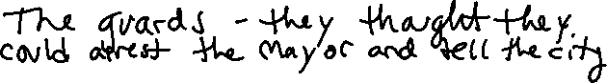

1. Describe Clary’s definition of darkness. How does she describe this darkness? ________________________________________________________________________________________________________________________________________________________________________________________________________________________



1. Define Egress according to Clary. ________________________________________________________________________________________________________________________________________________



1. Why was everyone let off work at 12 o’clock? ________________________________________________________________________________________________________________________________________________



1. What was the first clue Doon was able to find? ________________________________________________________________________________________________________________________________________________
2. What did Doon and Lina find the in the room next to the river that Doon had been hoping to find? What did they refer to it as? ________________________________________________________________________________________________________________________________________________
3. At the end of chapter 14, how will Lina and Doon leave Ember? ________________________________________________________________________________________________________________________________________________
4. When do Lina and Doon plan on telling the city about the way out? ________________________________________________________________________________________________________________________________________________
5. What did the worm do that Doon thought was curious? ________________________________________________________________________________________________________________________________________________
6. What caused Doon and Lina to change their plans drastically? ________________________________________________________________________________________________________________________________________________
7. What is Lina and Doon’s new plan? ________________________________________________________________________________________________________________________________________________________________________________________________________________________
8. Who are Lina and Doon trusting to tell the city about the boats and the way out? ________________________________________________________________________________________________________________________________________________
9. What happens at the very end of chapter 15? Do you think this will stop Lina and Doon from going through with their plan?

________________________________________________________________________________________________________________________________________________

Chapters 16-20

1. What caused Lina to run faster than she had ever run before in her life? ________________________________________________________________________________________________________________________________________________
2. Why did the guards take Lina to the mayor? ________________________________________________________________________________________________________________________________________________
3. What gave Lina the opportunity to escape from the mayor? ________________________________________________________________________________________________________________________________________________
4. How did Doon notify his father that he was leaving? ________________________________________________________________________________________________________________________________________________
5. What gave Doon a flash of joy when the lights went out? ________________________________________________________________________________________________________________________________________________
6. What were the two choices Doon had if Lina did not show up? Which did he prefer? ________________________________________________________________________________________________________________________________________________________________________________________________________________________
7. What made Lina feel brave again? Why? ________________________________________________________________________________________________________________________________________________
8. What did Lina find when she got out of the boat and climbed up the slope? ________________________________________________________________________________________________________________________________________________
9. Where did Lina tell Mrs. Murdo she was taking Poppy? Why did Lina tell her this? ________________________________________________________________________________________________________________________________________________________________________________________________________________________
10. What did Doon and Lina find in the beginning of chapter 19 that let them know they were on the right track? ________________________________________________________________________________________________________________________________________________
11. On page 252, what was the first clue that Lina noticed that something was different? ________________________________________________________________________________________________________________________________________________
12. At what time did Lina, Doon, and Poppy emerge from the path? How do you know? ________________________________________________________________________________________________________________________________________________
13. What was their reaction to seeing the sun? ________________________________________________________________________________________________________________________________________________________________________________________________________________________
14. What did Poppy find? What did it include? ________________________________________________________________________________________________________________________________________________
15. Why did the Builders create Ember? ________________________________________________________________________________________________________________________________________________
16. How many people were originally placed in Ember? ________________________________________________________________________________________________________________________________________________
17. What did Lina and Doon find when they went through the crack in the wall?

________________________________________________________________________________________________________________________________________________

1. How did Lina and Doon finally deliver their message? Who found it?

________________________________________________________________________________________________________________________________________________________________________________________________________________________