[](http://www.bing.com/images/search?q=stop+rewind+replay&FORM=HDRSC2#view=detail&id=F2827841DEC1202DE0765315270C11E02A2A309B&selectedIndex=297) **EXPLAIN YOUR THINKING**

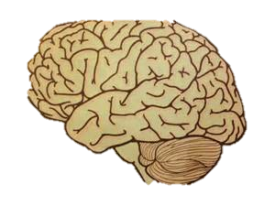

STOP. REWIND and REPLAY in SLOW motion as needed to

RECORD your thinking.

Students learn mathematical concepts through exploring problems, explaining their mathematical thinking and reflecting on their learning.

Develop a habit: Frequently explain how you got your answer ORALLY.

Ask your child about one or two problems on their math homework each night. This will help them build the habit of thinking about what they did.

**Problem solving model: (4 steps)**

**1) Understand the problem I know…**

▪ Reread the problem

▪ Identify the information given and the information that needs to be determined

▪ Discuss the problem to understand it better

**2) Make a plan I made a table to organize the two units…**

▪ Relate the problem to a similar problem solved in the past

▪ Consider possible strategies

▪ Select a strategy or a combination of strategies

**3) Carry out the plan**

**First I had to add the______ to find______ Then I multiplied… to find…**

▪ Try the chosen strategy

▪ Do the necessary calculations (addition, subtraction, multiplication, division)

▪ Draw pictures, use manipulatives

▪ Use numbers, words, pictures/symbols to represent the steps in carrying out the plan or doing the calculations

**4) Look back at the solution I knew my answer made sense because…**

▪ Check your answer

▪ Consider extensions or variations

▪ Describe how the solution was reached by explaining the solution