Chapter 4: Types of Reactions and Rates

Complete the definitions to the Terms:
- Activation Energy:
- Exothermic:
- Endothermic:
- Synthesis:
- Decomposition:
- Single displacement:
- Double displacement:
- Catalyst:
- Inhibitor:
Questions:
- What is the difference between exothermic and endothermic?

- Identify the four different types of chemical reactions below? Explain the difference between them.

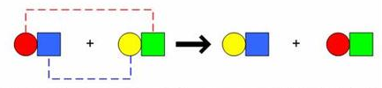

- Four factors that affect the Rate of Reaction

