Sixth Grade Supply List

2023-2024 🏫

(Please see the visual list and links on the second page!)

Necessary Items:

Three marble-covered composition books
- Oxford All-In-One Portfolio (eight pocket folder)
- Two dozen #2 pencils
- Highlighter(s)
- Colored pencils (no more than a 24-pack)

Headphones or earbuds
- Four or more thin-tipped dry erase markers
- Whiteboard eraser (or old sock)
- Two glue sticks
- Two large boxes of tissues (to be shared with class)

- Baby picture for the 6th grade yearbook—with name on back
- “School days” picture—individual, with a buddy, or in a small group—with name on back

---------------------------------------------------------------------------

Helpful Optional Items:
- Kid-safe scissors
- Black fine-point permanent marker
- TI-34 II calculator
- Pencil pouch
- Container of antibacterial wipes

Thanking you,
Our Appreciative Sixth Grade Team

Parents and Guardians:
Thank you in advance for weathering yet another back-to-school shopping experience. As parents and teachers, we feel your pain. If anything is unclear, please just send us an email. For convenience, all pictures are linked to Amazon, but feel free to purchase wherever you choose!
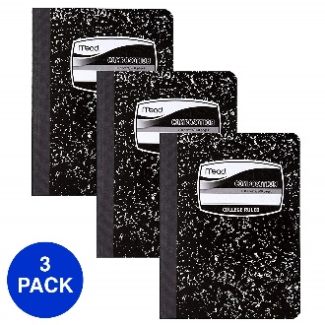  3 sewn-bound composition books | 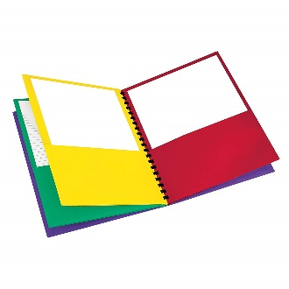  8 Pocket Portfolio Folder | 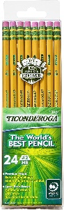  Two Dozen #2 pencils
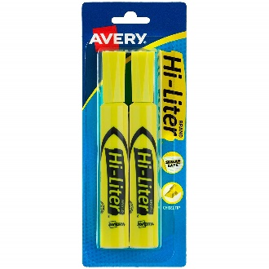  Two highlighters | 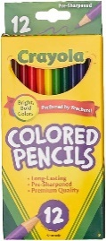  Colored Pencils  (24 or less) | 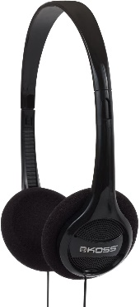  Headphones
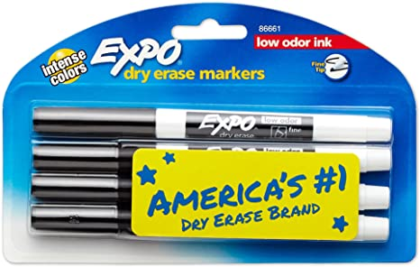  Four thin-tipped dry erase markers | 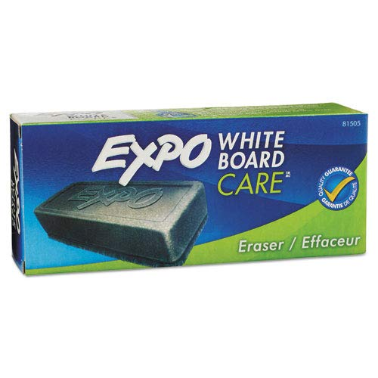  White board eraser or clean sock | 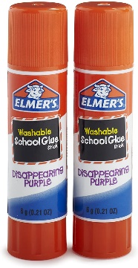  Two glue sticks
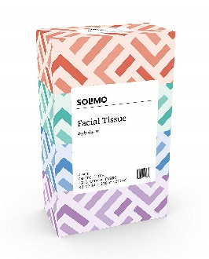  Two boxes of tissues | Optional:  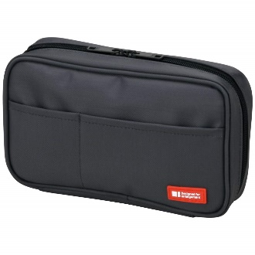  Soft Pencil Case | Optional:  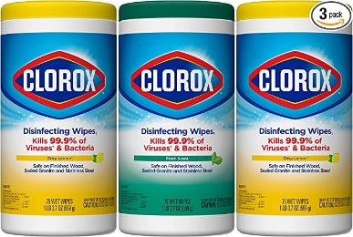  Clorox Wipes

