Name __________________________ Date __________
Unit 5 Review: Work, Energy & Power Academic Physics

Part I: Conceptual
- Define:
  - Work

  - Total (Mechanical) Energy

  - Kinetic Energy

  - Gravitational Potential Energy

  - Power

- Circle all of the following situations where the specified force does work on the specified object.

- A student lifting a backpack with an upward applied force.
- The upward normal force on a hockey puck as it slides across the ice.
- The tension force acting on a pendulum as it swings back and forth
- A student exerts an applied force to slide a cart across the floor.

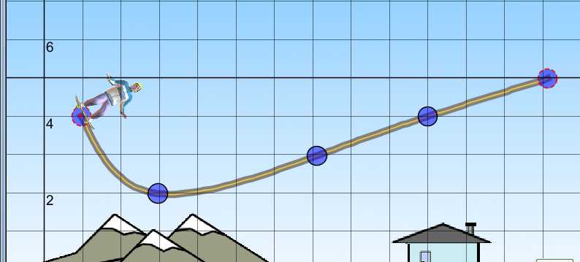
- A skateboarder starts at rest at point P. Describe the energy and motion of the skateboarder below at each point marked. Disregard the effects of friction.
D
P C
B
A

- What (in terms of energy conservation) would cause the skateboarder in the example above to slow down?

- A 20kg child starts from rest at the top of a slide with a potential energy of 500J. What will be the velocity of the child at the bottom of the slide which is at ground level?

- In terms of energy, what would make choosing a small hybrid car over a large SUV a good choice?

- Complete the table for the three different heights as the ball goes down the ramp. V₀ = 0m/s

K
P
E

9.53 kg

14.14 m

6.28 m

Part II Problems: Solve the following using methods demonstrated in class. SHOW ALL WORK.

USE THE ENERGY EQUATIONS

- Two 65kg students and a 12kg toboggan slide down a snow packed (frictionless) 12.4m high hill. If the sled starts from rest, what is its speed at the bottom of the hill?

- Determine the Potential Energy, Kinetic Energy and velocity at each point for a 1000 kg block that is released from rest. Be sure to show all work!
Pt A

37.5 m
Pt B

16.9 m

Pt C

- A 750 kg motorcycle accelerates from rest to 14m/s under the actions of two forces. One is the forward force of 540 N provided by the traction between the wheels and the road. The other is a 120 N resistive force due to various frictional forces.
  - How far does the motor cycle travel?
  - How long does it take for the motorcycle to reach this speed (hint: this requires equations from previous units)?

- Lightly and Flighty, two petite athletes, decide to race each other up the 5.5m high bleachers. Lightly, whose mass is 50 kg, makes the climb in 4.25 seconds; while Flighty, 65 kg, took 3.5 seconds to make the climb.

  - Calculate the work done to raise each athlete to top of the bleachers.

  - Calculate the power of each.

- A 72kg snowboarder rides a ski lift up a 50m high hill. She hops out and stands at the top of the hill.
  - How much gravitational potential energy does the snowboarder possess? Follow up: How much work was done by the lift to raise her to the top of the hill?

  - How fast will she be going at the bottom of the hill?

  - If she snowboards down the hill in 95 seconds, how much power is exerted by gravity?

- A ball (50g) starts at point A (35cm above the reference point) with a velocity of 5m/s and slides along a frictionless hill, eventually coming to a stop. Ignore friction. (Picture not drawn to scale)

A B
C
ref

  - Find the total mechanical energy of the system.

  - Find the velocity at point B (h= 17cm).

  - Find the velocity at point C (h = 0)

  - Find the maximum height the ball will go.

