Relaxation Exercises:

Calm Body Strategy

Tangled arms breathing

Bend arms and wrap one arm around the other twice if you can. Separate fingers in top hand and take 3 deep breaths and blow out. Feel the stretch in your back and shoulders.

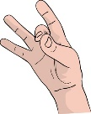[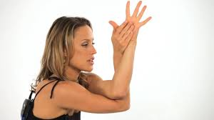](https://www.google.com/imgres?imgurl=https%3A%2F%2Fi.ytimg.com%2Fvi%2FfC9XQWc6ukk%2Fmaxresdefault.jpg&imgrefurl=https%3A%2F%2Fwww.youtube.com%2Fwatch%3Fv%3DfC9XQWc6ukk&docid=gMP8_UDvpa2YfM&tbnid=ZQH32VTQqMNvyM%3A&vet=10ahUKEwib-I6EsYDlAhUjT98KHS9gD54QMwiTASgzMDM..i&w=1280&h=720&hl=en&bih=624&biw=1301&q=child%20arm%20wrap%20pose&ved=0ahUKEwib-I6EsYDlAhUjT98KHS9gD54QMwiTASgzMDM&iact=mrc&uact=8)

Calm Body Strategy

Finger tapping & counting

Using 1 hand, press each finger to your thumb as you count to 16. As you tap each finger, repeat a positive phrase that has 4 words like: I have got this!

I am doing great!

Now, see if you can do it with both hands at the same time.

Then make a fist and stretch open your hands 5 times.