**Name: ______________________ Date: ________________**

**Photosynthesis Packet**

**Light-Dependent Reactions**

**Overview:**

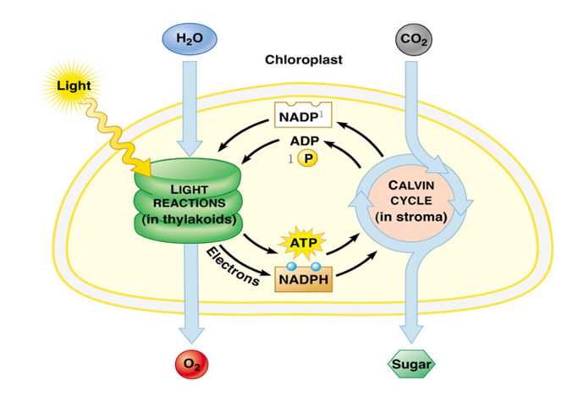

**1.** What occurs in the process of photosynthesis? ________________________________

________________________________________________________________________

________________________________________________________________________

1. Write the overall equation for photosynthesis using words. _____________________

________________________________________________________________________

**3.** Write the overall equation for photosynthesis using chemical formulas. ____________

________________________________________________________________________

**4.** Why does photosynthesis require in addition to water and carbon dioxide? _________

________________________________________________________________________

**6.** What is the principal pigment of plants? ___________________

**7.** Circle the letter of the region(s) of the visible spectrum in which chlorophyll absorbs light very well.

1. blue region
2. green region
3. red region
4. yellow region

**8.** Chloroplasts contain saclike photosynthetic membranes called ___________________.

**9.** What is a granum? _____________________________________________________

**10.** The region outside the thylakoid membranes in the chloroplasts is called the _______________________________________________________________________.

**11.** What are the two stages of photosynthesis called?

**a.** _______________________________________________________________

**b.** _______________________________________________________________

**12.** Complete the illustration of the overview of photosynthesis by writing the products and the reactants of the process, as well as the energy source that excites the electrons.



**14.** Circle the letter of the carrier molecule involved in photosynthesis.

**a.** H2O **c.** CO2

**b.** NADP+ **d.** O2

**15.** How does NADP+ become NADPH? ______________________________________

________________________________________________________________________

**Photosystems:**



**16.** Circle the letter of each sentence that is true about the light-dependent reactions. Correct the false statements.

1. They convert ADP into ATP.
2. They produce oxygen gas.
3. They convert oxygen into carbon dioxide.
4. They convert NADP+ into NADPH.

**17.** Where does the light-dependent reactions take place? _________________________

________________________________________________________________________

**18.** Why is it important for water to split in the light-dependent reaction?_____________

________________________________________________________________________

**19.** Circle the letter of each sentence that is true about the light-dependent reactions. *Correct the false statements*.

1. High-energy electrons move through the electron transport chain from photosystem II to photosystem I.
2. Photosynthesis begins when pigments in photosystem I absorb light.
3. The difference in charges across the thylakoid membrane provides the energy to make ATP.

**20.** What are the products of the light-dependent reactions? _______________________

_______________________________________________________________________

**21.** Why is it said that the sun is the ultimate source of energy?

_______________________________________________________________________

**22.** How does ATP synthase produce ATP? ____________________________________

________________________________________________________________________

________________________________________________________________________

**Light-Independent Reactions/ Calvin Cycle (Dark Reaction)**



**1.** Where does the Calvin cycle take place? ____________________________________

**2.** What happens to CO2 in the Calvin cycle? __________________________________

________________________________________________________________________

**3.** What are the inputs to the Calvin cycle? Where do they come from? ______________

________________________________________________________________________

________________________________________________________________________

**5.** Why are the reactions of the Calvin cycle called the light-independent reactions?

________________________________________________________________________

**6.** Circle the letter of each statement that is true about the Calvin cycle. Correct the false statements.

1. The main products of the Calvin cycle are six carbon dioxide molecules.
2. Carbon dioxide molecules enter the Calvin cycle from the atmosphere.
3. Energy from ATP and high-energy electrons from NADPH are used to convert 3-carbon molecules into similar 3-carbon molecules.
4. The Calvin cycle uses six molecules of carbon dioxide to produce a single 6-carbon sugar molecule.

**7.** What are the products of the Calvin cycle? __________________________________

________________________________________________________________________

**8.** What are uses for glucose in plants?

_____________________________________________________________________________________________________________________________________________

**Review of Photosynthesis**

