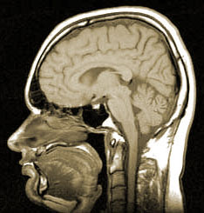
Medical Imaging - Web Lesson Name ____________________________________________
Basic Information about Medical Imaging → Resource - www.clermontradiology.com At bottom of page.
https://www.radiologyinfo.org/ Read about the different types of imaging available as you fill out the chart. Click on the top of page that says Test/Treatment. Then you may click on “ Search our complete index A-Z”
 | Write the complete name | How is the image made? | What type of structures can be viewed? | How does a person prepare for the test?
CT Scan
MRI
Ultrasound
X Ray
DEXA Scan
Careers in Medical Imaging → https://explorehealthcareers.org/
 | Job Description - Primary Functions (summarize 2) | Education Requirements | Average Salary
Radiologic Technologist
Diagnostic Medical Sonographer
Nuclear Medicine Technologist
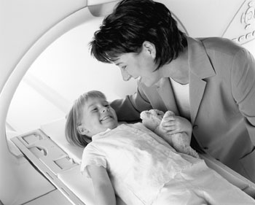
Career Self-Assessment → Find the link under “getting started” that asks “Is a medical career right for me?” What medical career is right for you? - You may want to browse some of the site’s other careers. Write a short essay that discusses a career option that would be a good fit for you.
_______________________________________________________________________________________________________________________________
_______________________________________________________________________________________________________________________________
_______________________________________________________________________________________________________________________________
_______________________________________________________________________________________________________________________________
_______________________________________________________________________________________________________________________________
_______________________________________________________________________________________________________________________________
_______________________________________________________________________________________________________________________________
_______________________________________________________________________________________________________________________________
_______________________________________________________________________________________________________________________________
_______________________________________________________________________________________________________________________________
_______________________________________________________________________________________________________________________________
_______________________________________________________________________________________________________________________________
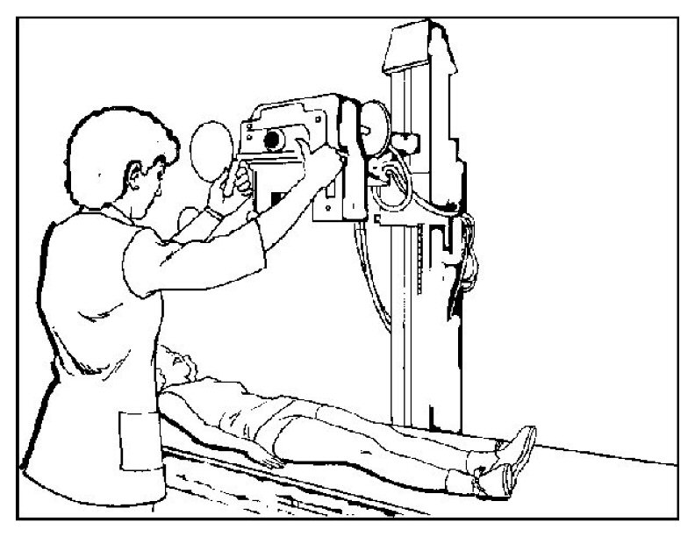
_______________________________________________________________________________________________________________________________
X RAY Images → www.biologycorner.com/flash/xray.html
Diagnosis 1 __________________________________________________________
Diagnosis 2 __________________________________________________________
Diagnosis 3 _________________________________________________________
Diagnosis 4 _________________________________________________________

