USING PASCO CAPSTONE SOFTWARE

1. Load the PascoCapstone software
2. Turn your blue/red cart on (there is a button on the side).

(the bluetooth light will intermitantly blink)

1. Click on the “hardware setup” button (see picture below). You will see a list of available wireless devices. Select the cart that matches the number on the top of your cart.

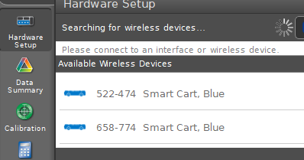

1. Toggle the smart cart accelerometer sensor and the gyro sensor off by clicking the tab.

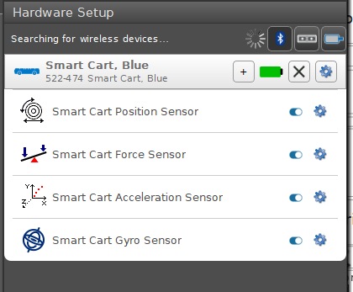

1. Click the hardware setup button again so the hardware setup menu goes away.
2. Click on the calibration button and calibrate the force probe.

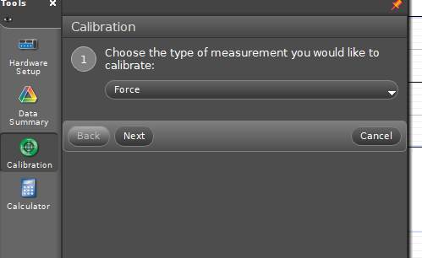

1. Click NEXT and NEXT (make sure 2 points is selected). You will see a spot to enter a standard value. Enter 0 (zero may already be the default). MAKE SURE NOTHING IS ON THE HOOK. Click on “set current value to standard value”.
2. A second calibration will come up. This time we are going to enter 4.41 N as a value (instead of 0). BEFORE you click the “set” button, you must put 400 grams on the 50 gram hook. Allow this mass to hang from the hook at rest. Then click “set current value to standard value”.
3. Click the calibration button again for the calibration menu to disappear.
4. We need to display 2 graphs, so choose the lower left choice with 2 options.

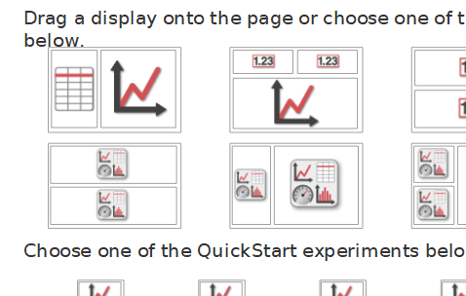

1. Click on each individual button and select graph for each one. (it is the first choice).
2. On the “Y-axis” Choose the graphs you wish to see. (for the modified Atwood one of the graphs should be force and the other should be velocity)
3. Before starting the experiment, you should ZERO the force probe. Once again choose hardware setup and click on the “settings” picture next to force sensor.



1. Click “zero sensor now” and hit OK. (clicking on hardware setting again will make the menu go away)
2. To start recording, click the record button near the bottom left, and click it again to stop.

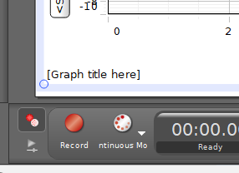

1. To analyze data, you will need to select a highlight ‘box’ by clicking the button at the top of the graph that has a yellow highlighter. Drag and reshape the box to the size you want, and over the desired graph you wish to analyze.

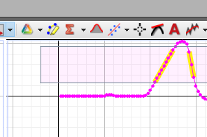

1. For slopes, click the down arrow on the below icon, and select linear fit. Then to get the value, click on the actual “line and dot” picture.

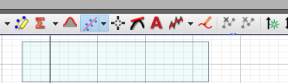

1. For averages, maxs and mins, click on the arrow next to the SIGMA and choose the desired values. Checking it a second time will “uncheck” it. Once the section you desire is highlighted, click on the acutal SIGMA to see the values.
2. Before you start your next run, click on the “delete latest run” button near the bottom left. Then click record.

