### Monday morning Summer practices:

Weekly Monday morning practices will be held at Peace Valley Park at the boat rental parking lot on the south side at 8:00 AM sharp. (see map below for location and directions)

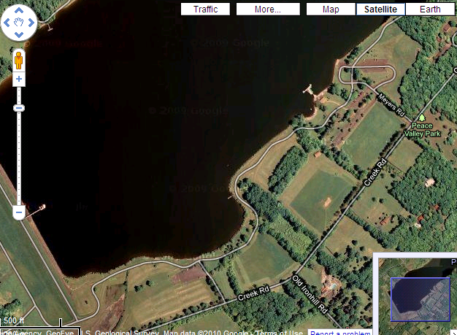

Monday mornings 8am

Lot near marina

|  |  |  |  |
| --- | --- | --- | --- |
| DIRECTIONS:  From: 1100 Folly Rd, Warrington, PA 18976 | | | |
| 1. | Head **northeast** on **Folly Rd** toward **Bristol Rd** | http://maps.gstatic.com/intl/en_us/mapfiles/cb/camera_dr1.png | 0.3 mi |
| 2. | Turn **left** at **Bristol Rd** | http://maps.gstatic.com/intl/en_us/mapfiles/cb/camera_dr1.png | 2.8 mi |
| 3. | Turn **right** at **W Butler Ave** | http://maps.gstatic.com/intl/en_us/mapfiles/cb/camera_dr1.png | 1.1 mi |
| 4. | Turn **left** at **Keeley Ave** | http://maps.gstatic.com/intl/en_us/mapfiles/cb/camera_dr1.png | 0.5 mi |
| 5. | Continue onto **Old Ironhill Rd** | http://maps.gstatic.com/intl/en_us/mapfiles/cb/camera_dr1.png | 0.5 mi |
| 6. | Turn **right** at **Ferry Rd** | http://maps.gstatic.com/intl/en_us/mapfiles/cb/camera_dr1.png | 26 ft |
| 7. | Take the 1st **left** onto **Old Ironhill Rd** | http://maps.gstatic.com/intl/en_us/mapfiles/cb/camera_dr1.png | 0.4 mi |
| 8. | Turn **right** at **Creek Rd** | http://maps.gstatic.com/intl/en_us/mapfiles/cb/camera_dr1.png | 0.3 mi |
| 9. | Take the 1st **left** onto **Meyers Rd** | http://maps.gstatic.com/intl/en_us/mapfiles/cb/camera_dr1.png | 0.1 mi |