Math-Day 10 (Grade 6)
Fact Practice
- Pick one of the fact practices to complete. It does not have to be timed. This should be the tenth fact practice.
Math in Focus
Overview: Negative numbers and absolute value
Estimated Time: Approximately 30 minutes
Explanation: Today you will review Negative Numbers and complete some worksheets to practice your knowledge of negative numbers and the number line. You will also complete a worksheet on absolute value.
Tasks:
- Continue recording the daily temperature on your chart.
- Review the information above.
- Complete the worksheets that I emailed to you.
Things to know:
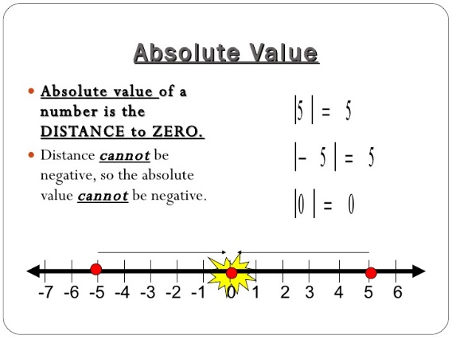
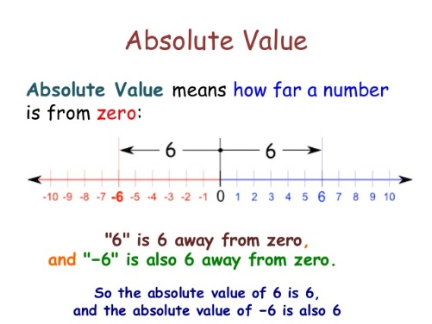
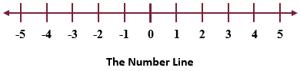

- Extra: Only do this activity if you want more practice.
· play “MinusMania” at https://www.gregtangmath.com/minusmania
· play “Kakooma” at https://www.gregtangmath.com/kakooma
· play “MathLimbo” at https://www.gregtangmath.com/mathlimbo

