Tomorrow I’ll be BRAVE
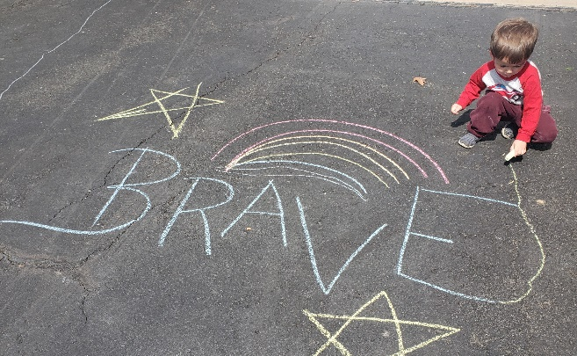
Reflections and follow up discussion

- What does it mean to YOU to be brave? How have you been brave during the past few weeks?

- Can we still be brave even though we are afraid or scared?

- In the book, it also mentions the following words; adventurous, curious, strong and creative. Can you think of examples of showing these character traits? For example; what is something new or adventurous you’ve tried during the past few weeks? Maybe trying a new food or a new hobby?

BORED AND LOOKING FOR SOMETHING FUN TO DO OUTSIDE?

Click this link to watch Mrs. Thompson show you how to make this book into a fun, easy game with your family!

https://www.youtube.com/watch?v=-7RM1ZxFCAw

