Name: ____________________________________

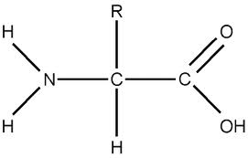**Proteins**



1. **How many amino acids are pictured above?_________**
2. **Circle the amino group with a red colored pencil.**
3. **Circle the carboxyl group with a green colored pencil.**
4. **Circle the R group blue. What does the “R” represent? ______________________________**
5. **What is removed when 2 amino acids are joined? __________________________________**
6. **In orange circle where the above 2 amino acids would join.**
7. **What type of reaction is this? __________________________________________________**
8. **The bond that joins the 2 amino acids is called a ___________________________________.**
9. **When 2 amino acids are joined by a peptide bond it is called a ________________________.**
10. **When 3 amino acids are joined by a peptide bond it is called a ________________________.**
11. **When several amino acids are joined it is called a ___________________________________.**