Name: ____________________________

**Lipids**

1. **What are the building blocks of a lipid molecule? _____________________________________**
2. **In the image below, circle the glycerol molecule in green and draw a box around the fatty acid chains in orange.**

[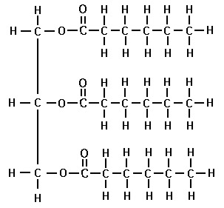](http://www.google.com/url?sa=i&rct=j&q=&esrc=s&frm=1&source=images&cd=&cad=rja&docid=0G2U7JKHOGvvbM&tbnid=IquaFFazu5pUlM:&ved=0CAUQjRw&url=http://gaia-health.com/gaia-blog/2012-10-20/there-is-only-one-type-of-cholesterol-heres-why/structure-of-triglyceride-molecule/&ei=12guUei_Fa290QHm_oDQCw&bvm=bv.42965579,d.dmQ&psig=AFQjCNFXEtxOXd0s1E2CJVIUYdIBONoW5g&ust=1362082376785771)

1. **What type of lipid is pictured above? ______________________________________________**
2. **How would a phospholipid look different? ___________________________________________**

**______________________________________________________________________________**

1. **Formation of a lipid: Look at the equation below. Notice that a large molecule is made and water is removed in the process. What name could we give this reaction?**

**_______________________________________**

[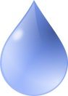](http://www.google.com/url?sa=i&source=images&cd=&cad=rja&docid=2Nxq6opoOF4BAM&tbnid=d6KFRR8iO0PXhM:&ved=0CAgQjRwwAA&url=http://free.clipartof.com/details/62-Free-Water-Drop-Clipart-Illustration&ei=W2ouUYmdHZGx0QHBnoD4CQ&psig=AFQjCNHQc9BSiS_n5vsA64HWS2Z19b6Kvw&ust=1362082779738819)[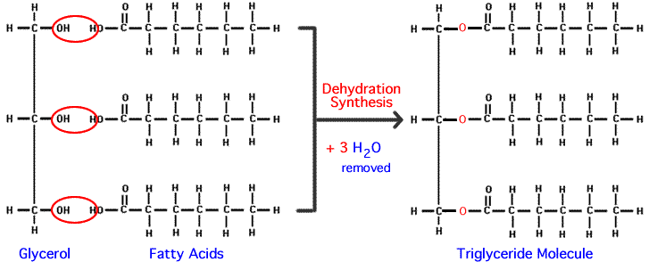](http://www.google.com/url?sa=i&rct=j&q=&esrc=s&frm=1&source=images&cd=&cad=rja&docid=UOvfRkEGn6dQDM&tbnid=gl1ZG7-kNHdRlM:&ved=0CAUQjRw&url=http://science.halleyhosting.com/sci/ibbio/chem/notes/chpt3/triglyceride.htm&ei=QGkuUf6CK8mE0QHDtIGYDg&bvm=bv.42965579,d.dmQ&psig=AFQjCNGFmrIxY_J565hSCRYQeNVjkN6lKw&ust=1362082493417758)[](http://www.google.com/url?sa=i&rct=j&q=&esrc=s&frm=1&source=images&cd=&cad=rja&docid=UOvfRkEGn6dQDM&tbnid=gl1ZG7-kNHdRlM:&ved=0CAUQjRw&url=http://science.halleyhosting.com/sci/ibbio/chem/notes/chpt3/triglyceride.htm&ei=QGkuUf6CK8mE0QHDtIGYDg&bvm=bv.42965579,d.dmQ&psig=AFQjCNGFmrIxY_J565hSCRYQeNVjkN6lKw&ust=1362082493417758)

**3 H2O**