**Carbohydrates**

1. **List the three most common types of monosaccharides:________________________________**
2. **Both images below are the structural formulas for glucose. Circle the hydroxyl groups.**

[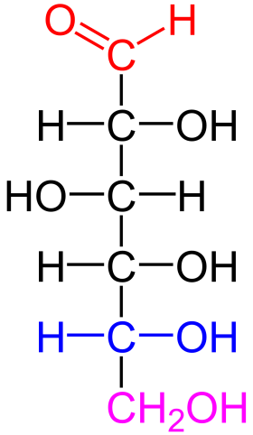](http://www.google.com/url?sa=i&rct=j&q=glucose&source=images&cd=&cad=rja&docid=FX0xGW0Px3uPEM&tbnid=vSZlN3GogKIoGM:&ved=0CAUQjRw&url=http://en.wikipedia.org/wiki/File:D-glucose_color_coded.png&ei=PrwsUfSeKMny0wHz8YAQ&bvm=bv.42965579,d.dmQ&psig=AFQjCNFO9UJQj_pPcIxGZIGYq37z96K3dQ&ust=1361972633580745)[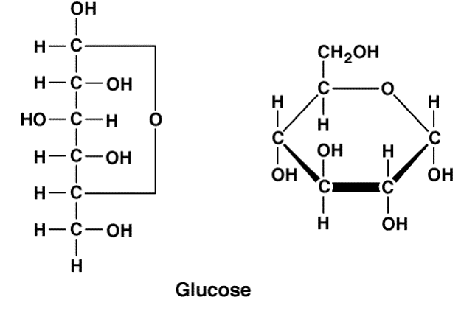](http://www.google.com/url?sa=i&rct=j&q=glucose&source=images&cd=&cad=rja&docid=Ghdhg0aYImEebM&tbnid=Qe1RumZ7LKxbgM:&ved=0CAUQjRw&url=http://drpinna.com/hey-dr-mirkin-is-high-fructose-corn-syrup-bad-9398/glucose-2&ei=i7wsUcKKDKS-0AH_-4GQCQ&bvm=bv.42965579,d.dmQ&psig=AFQjCNFO9UJQj_pPcIxGZIGYq37z96K3dQ&ust=1361972633580745)

1. **What is the chemical formula for glucose?___________________________________________**
2. **Fructose and galactose are isomers of glucose. Knowing this, what are the chemical formulas of fructose and galactose? ________________________________________________________**
3. **List the three most common types of disaccharides: ___________________________________**
4. **List the three most common types of polysaccharides: _________________________________**
5. **The following is a picture of a dehydration synthesis reaction:**

[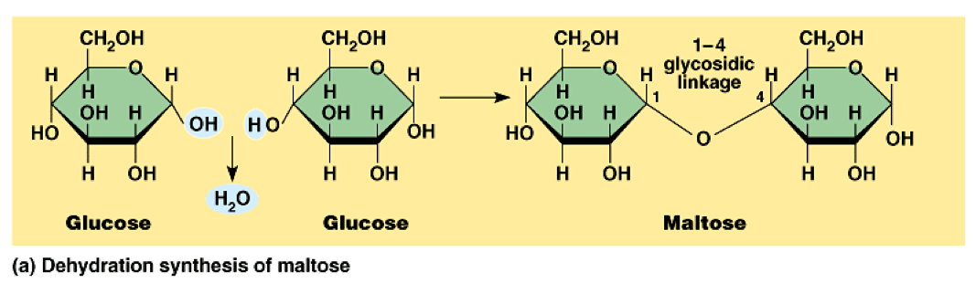](http://www.google.com/url?sa=i&rct=j&q=glucose+dehydration+synthesis&source=images&cd=&cad=rja&docid=dARtUdp4Qx2BMM&tbnid=3qI4CbXcLKR-0M:&ved=0CAUQjRw&url=http://www.studyblue.com/notes/note/n/chapter-5-8-review/deck/4351260&ei=NL4sUc-pM8jH0QHusIGYBQ&psig=AFQjCNGZ_yqldzRmZ3TWjsrPJo-bkGmucw&ust=1361973002158128)

**Summarize dehydration synthesis: _________________________________________________**

**______________________________________________________________________________**

1. **The following is a picture of a hydrolysis reaction:**[](http://www.google.com/url?sa=i&rct=j&q=glucose+dehydration+synthesis&source=images&cd=&cad=rja&docid=dARtUdp4Qx2BMM&tbnid=3qI4CbXcLKR-0M:&ved=0CAUQjRw&url=http://www.studyblue.com/notes/note/n/chapter-5-8-review/deck/4351260&ei=NL4sUc-pM8jH0QHusIGYBQ&psig=AFQjCNGZ_yqldzRmZ3TWjsrPJo-bkGmucw&ust=1361973002158128)**[](http://www.google.com/url?sa=i&rct=j&q=glucose+dehydration+synthesis&source=images&cd=&cad=rja&docid=dARtUdp4Qx2BMM&tbnid=3qI4CbXcLKR-0M:&ved=0CAUQjRw&url=http://www.studyblue.com/notes/note/n/chapter-5-8-review/deck/4351260&ei=NL4sUc-pM8jH0QHusIGYBQ&psig=AFQjCNGZ_yqldzRmZ3TWjsrPJo-bkGmucw&ust=1361973002158128)**[](http://www.google.com/url?sa=i&rct=j&q=glucose+dehydration+synthesis&source=images&cd=&cad=rja&docid=dARtUdp4Qx2BMM&tbnid=3qI4CbXcLKR-0M:&ved=0CAUQjRw&url=http://www.studyblue.com/notes/note/n/chapter-5-8-review/deck/4351260&ei=NL4sUc-pM8jH0QHusIGYBQ&psig=AFQjCNGZ_yqldzRmZ3TWjsrPJo-bkGmucw&ust=1361973002158128)

**Summarize hydrolysis: __________________________________________________________**

**_____________________________________________________________________________**