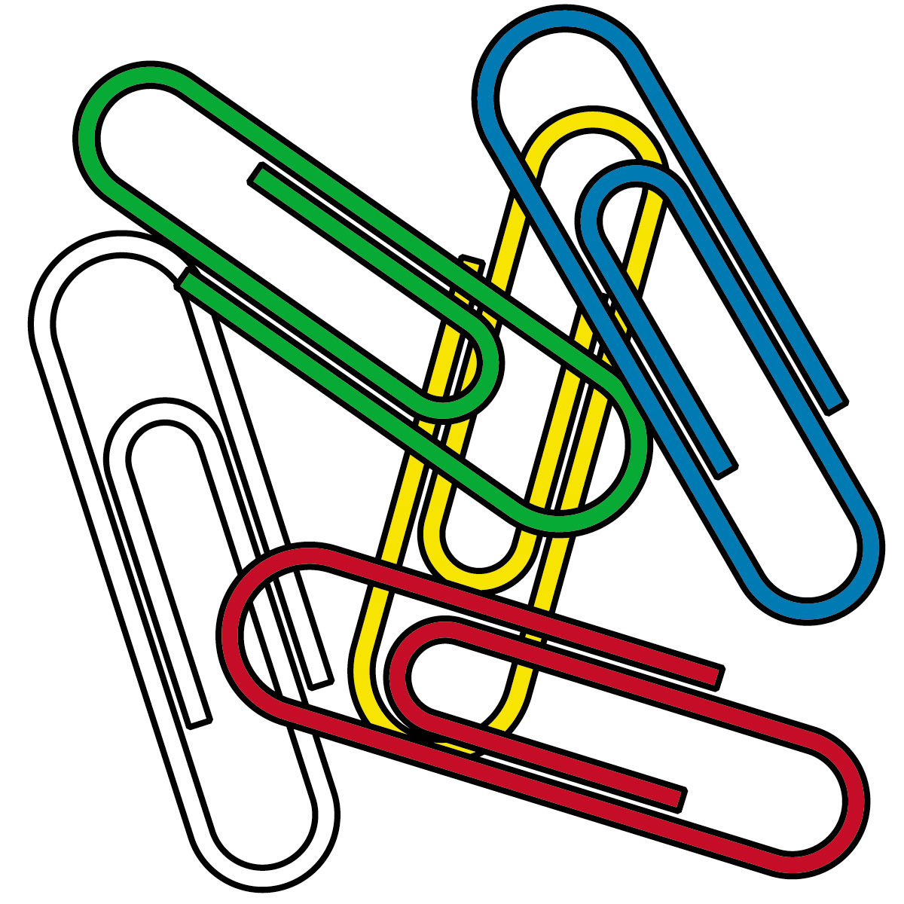
Clipase!

Enzyme Activity Simulation

Background:
Enzymes are specialized proteins. They reduce the activation energy, or the amount of energy needed to start a chemical reaction in an organism. Enzymes are the helpers that speed up chemical reactions: They assist in building bonds (to make larger compounds), or breaking bonds. The reactants that an enzyme works with are called substrates.
There are millions of different kinds of enzymes. Each of these enzymes has a unique function and works best under specific conditions. The conditions that can affect an enzyme’s activity are temperature, concentration and pH.

Objective:
You will simulate the functionality of an enzyme under different conditions.
You will describe how different temperatures, concentrations, and pH
values can affect the functionality of the imaginary enzyme, “Clipase.”

Hypothesis:
- As substrate concentrations decrease over time, an enzyme’s activity will ____________________.
- A change in pH will cause an enzyme’s activity to ____________________.

The Simulation:
Your hands are an enzyme called “Clipase.” (Enzymes are typically named after the function or chemical they work with and end in –ase). The function of clipase is to connect two paperclips. The rate of reaction of clipase will be tested under two different conditions—over time (60 seconds), and change in pH. Data will be collected, analyzed and discussed.
Your partner will be a different enzyme called “Declipase.” The function of declipase is to separate two paperclips. The rate of reaction of declipase will be tested over time (60 seconds). Data will be collected, analyzed and discussed.

Procedure:

Part I: Clipase Rate of Reaction
- When told, begin “reacting with the paperclips” (connecting two paperclips together as fast as you can).
  - Do NOT connect more than two together
  - Keep all paperclips in container
  - Do NOT bend or deform paperclips
- After the first 20 second interval, record the number of paperclips you reacted with in the data table.
- Repeat for the remaining intervals, your teacher will time the intervals.

Part II: Declipase Rate of Reaction
Most enzymes can only perform a single specific function. Therefore, you will need to switch positions with a partner. Your partner will simulate “Declipase” and have to unclip the paperclips.
- When told, begin “reacting with the paperclips” (separating the paperclips as fast as you can).
  - Keep all paperclips in container
  - Do NOT bend or deform paperclips
- After the first 10 second interval, record the number of paperclips you reacted with in the data table.
- Repeat for the remaining intervals, your teacher will time the intervals.

Part III: pH Change
A drastic change in pH will cause the enzyme to change its structure. As you know, a change in structure will cause a change in function. To demonstrate this effect, you CANNOT use your THUMBS to attach paperclips! Repeat the above steps and record your data.

Name __________________ Date __________ Block ____

Clipase!

Enzyme Activity Simulation Results

Hypothesis: Data:
- As substrate concentrations decrease over time, an enzyme’s activity will ____________________.  - A change in pH will cause an enzyme’s activity to ____________________. | Paperclips metabolized under various conditions.
   | Paperclips metabolized
  20 sec Intervals | Clipase | Declipase | pH Change of Clipase
  0
  1
  2
  3
  4
  5
  6

Graph your data on the graph paper provided. Use a line graph with a different color to represent Clipase, pH change of Clipase, and Declipase.

Analysis questions:

- What was the active site, substrate and product for Clipase?

- What was the active site, substrate and product for Declipase?

- What happens to the rate of reaction as the concentration of products increases? In other words, what happened to the rate of the reaction as time got closer to 120 seconds?

- What happens to the rate of reaction as the pH changes? (Hint: that is when you couldn’t use your thumbs.)

- What happens to the structure and function of an actual enzyme if the pH or the temperature is changed?

