Photosynthesis & Cellular Respiration Worksheet

Name:__________________________________________Period:_______

*Vocabulary: Match the phrases on the left with the term that best fits. Use answers only one time.*

**____**1. Organisms that make their own food **A.** Chloroplasts

____2. Site of photosynthesis **B.** Aneorobic

____3. Process occurs in a mitochondrion **C.** Aerobic

____4. C6H12O6 **D.** Glucose

____5. Process does not require oxygen **E.** ATP

____6. Process requires oxygen **F.** Kreb’s cycle

____7. Adenosine diphosphate **G.** Glycolysis

____8. Energy storing molecule **H.** Energy

____9. The anaerobic process of splitting glucose **I.** ADP

and forming two molecules of pyruvic acid

**J.** Autotrophs

____10. The ability to do work

*Directions: Answer each of the following questions in a clear and concise manner.*

1. Compare and discuss how cells store energy and release energy using ATP. Be specific! You may draw the cycle.

2. Using the following word bank, fill each word under the proper heading.

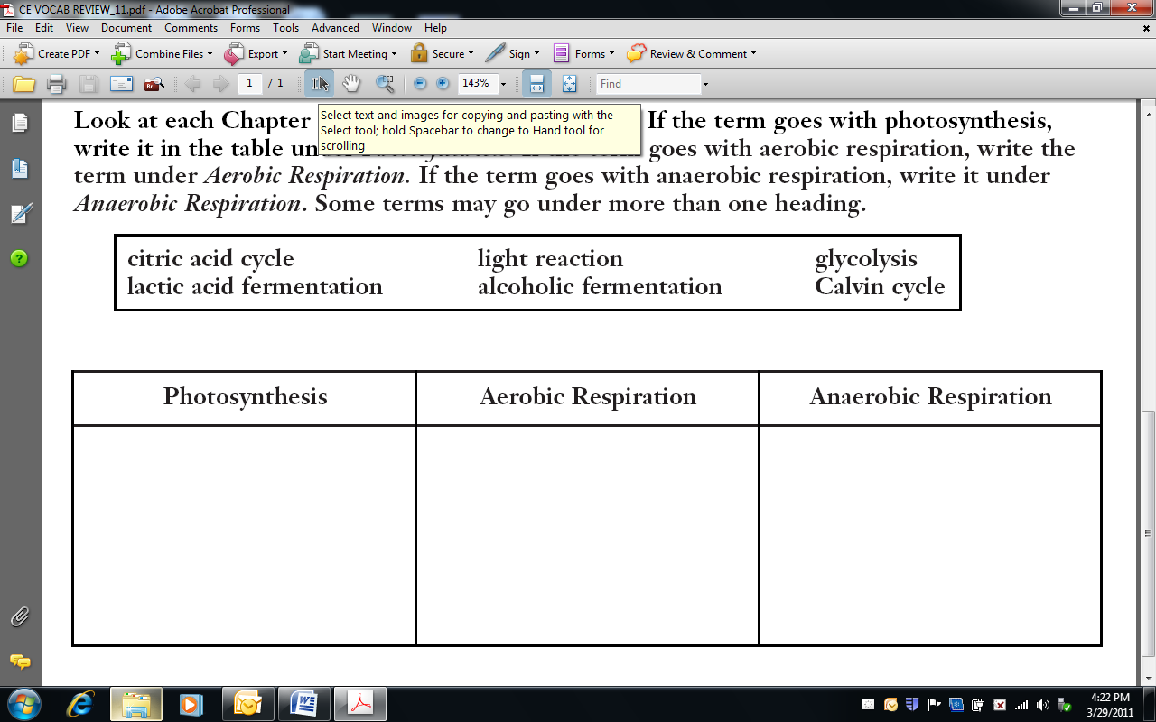

3. Name the three processes of aerobic cellular respiration. How many ATP’s does each process produce, and what is the total ATP produced from one glucose?

|  |  |
| --- | --- |
| **3 Processes of Cellular Respiration:** | **# ATP produced:** |
|  |  |
|  |  |
|  |  |

**Total ATP per 1 glucose** =__________

4. Name the two stages of photosynthesis and list the starting molecule(s) and ending molecule(s) of each.

|  |  |  |
| --- | --- | --- |
| **Stages** | **Starting Molecule(s)** | **Product(s)** |
|  |  |  |
|  |  |  |

5. What is the general chemical equation of photosynthesis?

6. When and why does our body use lactic acid fermentation?

7. Explain how the equations for photosynthesis and aerobic respiration compare.