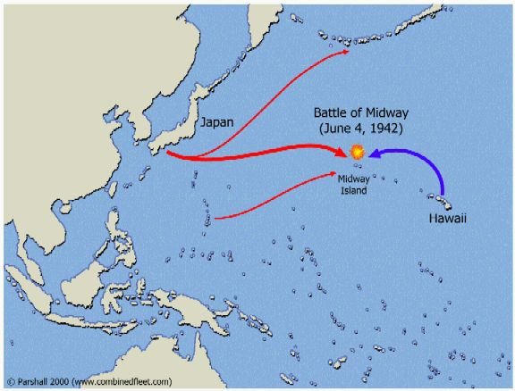

**South Pacific 1942**

**Battle of Midway**