Phase Diagram Worksheet

Refer to the phase diagram below when answering the questions on this worksheet:

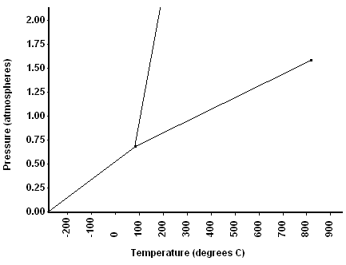

1) What is the normal freezing point of this substance?

2) What is the normal boiling point of this substance?

3) What is the triple point of this substance?

4) If I had a quantity of this substance at a pressure of 1.25 atm and a temperature of 300⁰ C and lowered the pressure to 0.25 atm, what phase transition(s) would occur?

5) At what temperature do the gas and liquid phases become indistinguishable from each other?

6) If I had a quantity of this substance at a pressure of 0.75 atm and a temperature of -100⁰ C, what phase change(s) would occur if I increased the temperature to 600⁰ C? At what temperature(s) would they occur?
Phase Diagram Worksheet Answers

Refer to the phase diagram below when answering the questions on this worksheet:

1) What is the normal freezing point of this substance? 100⁰ C

2) What is the normal boiling point of this substance? 375⁰ C

3) What is the normal freezing point of this substance? .74atm & 95⁰C

4) If I had a quantity of this substance at a pressure of 1.25 atm and a temperature of 300⁰ C and lowered the pressure to 0.25 atm, what phase transition(s) would occur?
It would vaporize at a pressure of ~0.75 atm.

5) At what temperature do the gas and liquid phases become indistinguishable from each other? 825⁰ C

6) If I had a quantity of this substance at a pressure of 0.75 atm and a temperature of -100⁰ C, what phase change(s) would occur if I increased the temperature to 600⁰ C? At what temperature(s) would they occur?
It would melt at ~100⁰ C, then boil at ~175⁰ C.

