1. 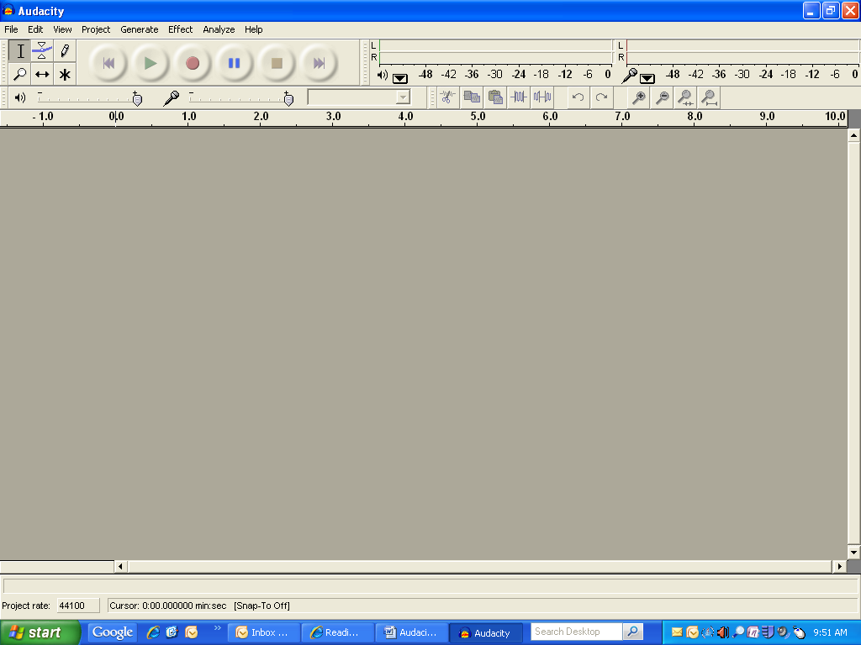Open up Audacity. [](http://www.bing.com/images/search?q=audacity#focal=cafcd6eeb109acd3842ab157cd3c8ba8&furl=http://linuxcrazy.com/audacity.png)
2. Press Record button when you are ready to begin reading.
3. Make sure you are reading close enough to the microphone!
4. Read fluently!
5. When you are finished, press Stop.



1. Press the Play button and listen to yourself read.
2. 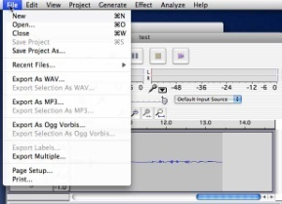Make two goals for the week.
3. Go to File and Select Export as mp3.
4. Select your folder.
5. Type your name and the number of the month and day (Ex: MissWhite0926)
6. Press Save.
7. Type your name and number one more time in title box. Press Ok.
8. YOU DID IT! Get the next person!