Sharing With SeeSaw: Signing in

- Open Chrome or Edge  - Type cbsd.org/365 or myapps.microsoft.com  - Login with your student email schoollogin@student.cbsd.org  - Type in the password you use at school | Sample Login:  Jansen.c345@student.cbsd.org
- Select Clever  - Click on the box that says “Login with Active Directory” | 
- Click on your name in the top left corner of the page  - You will see a list of your classes. | 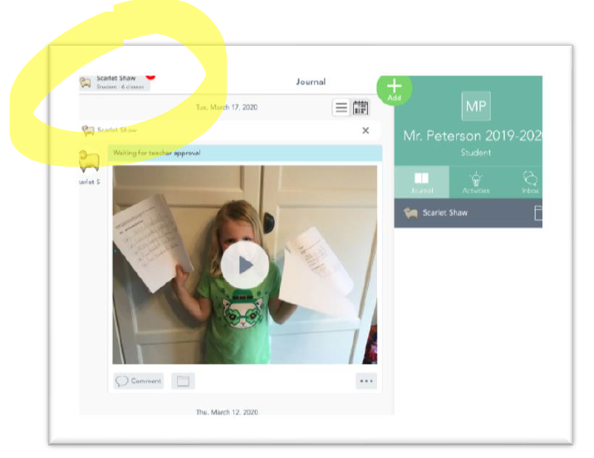
- Select the Class that you want to post to.  - Click on the + to post a new activity.  - Once you post it, your teacher will approve it for you to add to your journal. | 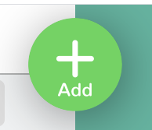  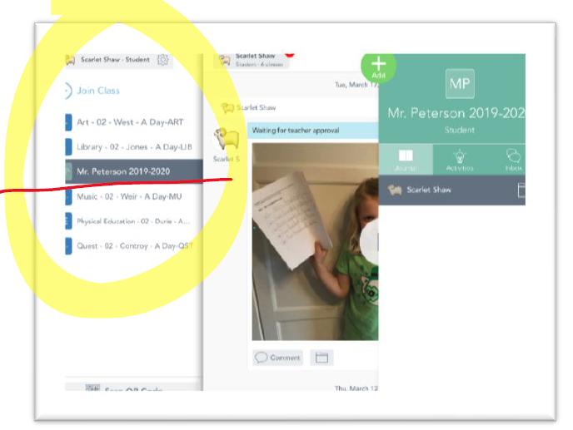

See the next page for how to Sign out
Sharing With SeeSaw: Signing OUT

Your child will need to Sign Out of Seesaw Class app so multiple children can use the same app and/or device.

Open the Seesaw App and locate the student’s name in the upper left-hand corner | 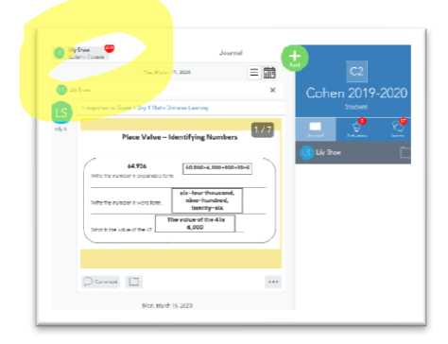
Click on your name and you will see more options like more Journals/Classes and the Gear Icon | 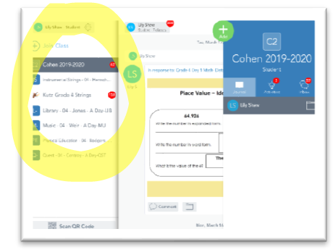
- Select the Gear icon (Settings)    - Select Sign Out Select Sign Out again | 