 **Projectiles Practice**

1. What force(s) are acting on a football as it is in mid-air?

(ignore air resistance)

A) gravity B) normal C) tension



D) applied E) friction F) magnetic

2. Draw a free body diagram for this projectile in mid-flight thrown by Super Bowl MVP Nick Foles 😊.



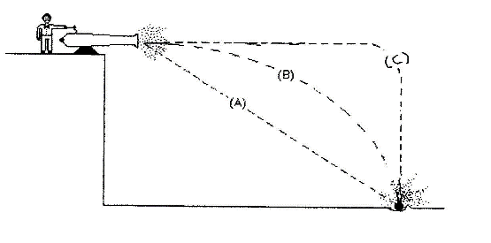3. What path will the cannonball take?



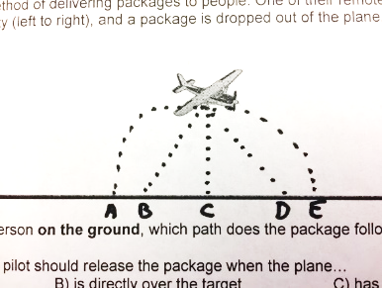4. A plane drops a Dasani bottle while it is flying from left to right. What path will the bottle take on its way to the ground?



5. Mr. Freed is driving his car at 50 mph. Just to get crazy, he throws up a tennis ball in the air. Ignoring air resistance, where will the ball land?

A) behind the car B) in the car C) in front of the car



6. Bob fires a gun horizontally and drops another bullet from the same height. Which one hits the ground first?

A) the dropped one B) the fired one C) they hit at the same time



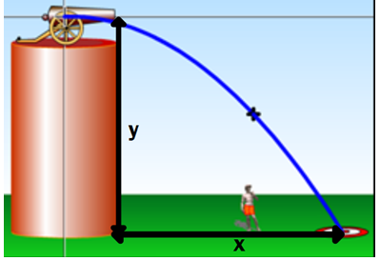**y = 4.9 t2 x = vt**

7) A cannon is fired from a rifle that is held 1.6m above the ground. The initial speed of the bullet is 1100 m/s.

a) find the time it takes for the cannonball to strike the ground.

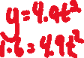

b) find the horizontal distance traveled by the cannonball.



8) A golf ball rolls off a cliff. The ball falls a vertical distance of 15.5 m into a lake below. How much time does the ball spend in the air?



9) In 2010 Aroldis Chapman threw the fastest recorded pitch at 46.8 m/s, and the catcher was 18.4 meters away. How much did the baseball drop vertically?



10) A car drives straight off the edge of a cliff that is 54 m high. The police at the scene of the accident note that the point of impact is 130 m from the base of the cliff. If the speed limit on the road is 20 m/s, was this car speeding? (Hint: compare your answer for velocity to the speed limit.)

