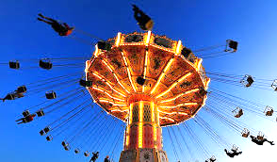
Circular Motion Problems

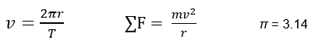

1) Fill in the chart for each symbol.

Symbol | Name | Unit
v
$$∑F$$
r
T
m

2) Every object moving in a circle has a net force acting on it toward what part of the circle?

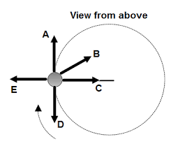
3) We are looking from the top down at a car driving clockwise in a traffic circle. The car goes over an ice patch and loses all friction with the road. Which direction will the car go?

4) What type of force keeps the following objects in the circle?
(Choices are friction, tension, or gravity)

A) The space station is orbiting Earth.
B) A track and field athlete is running around the curved track at East.
C) A dog is running in a circle, but his leash is attached to a stake in the ground.

5) A 1300kg car is driven around a circular track which has a radius of 100m. The car makes one lap in a time of 25 seconds.

a) How fast is the car moving?

b) How many Newtons of net centripetal force are acting on the car?

6) Batman is chasing Mr. Freeze around the streets of Gotham City in his 2000kg Batmobile. Mr. Freeze covers the 30-meter radius curved road with frictionless ice. To negotiate the corner, Batman shoots a 30m long cable out from the side of the Batmobile that wraps around a lamp post on the inside of the corner.

a) If the maximum tension the cable can withstand without breaking is 30,000N, what is the maximum speed Batman can go around the corner?

b) What happens if you exceed the amount of tension force for a rope?

c) When this happens, what direction will the Batmobile go?

7) A 10 kg dog is chasing his tail in a circle with a radius of 2 m, and it takes him 3.5 seconds to make a complete circle. How many Newtons of friction with the ground does the dog need to stay in the circle?
(Hint: this is a 2-step problem, it’s not too bad, there’s only 2 equations ( ͡° ͜ʖ ͡°))

