**SAT/ACT PREP—VERBAL: COURSE DESCRIPTION**

This SAT/ACT preparation course is designed to improve a student's skills in vocabulary in context, reading comprehension and critical analysis, essay writing, and grammar, usage, and conventions of language. A participant in this course is expected to demonstrate improvement in word attack skills, increased reading comprehension and analysis skills, and improved composition and mechanics skills. After completing practice SAT/ACT tests, each student will evaluate his/her skills and test taking strategies.

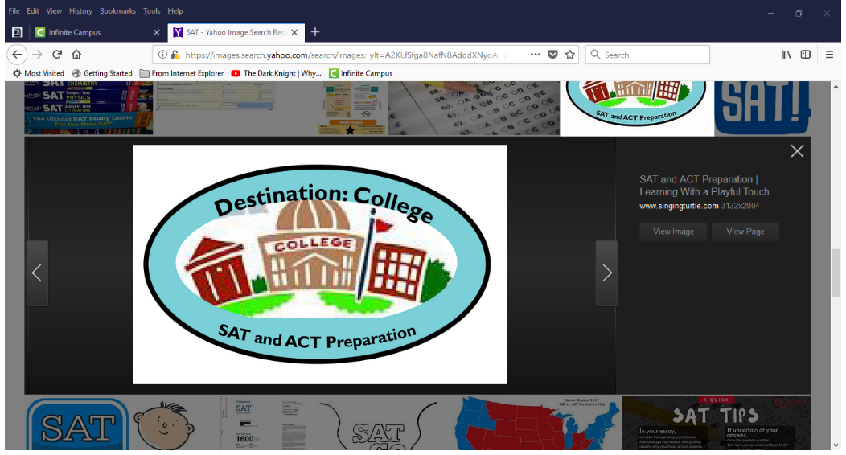

**COURSE OVERVIEW**

* ***Vocabulary Development:*** Vocabulary-in-context skills, practical vocab words across disciplines, and understanding word choice as it relates to tone and clarity.
* ***Reading Comprehension and Analysis:*** Analysis of overall text structure, part to whole relationships, point of view, purpose, and argument. Close reading skills, determining explicit/implicit meanings, main ideas, themes, and citing textual evidence and quantitative information.
* ***Grammar:*** Review of various grammar rules, how to use them correctly within essays, how to recognize them on the writing multiple choice portion of the SAT and ACT, and how to improve the development, organization, and diction in the passages in order to ensure they conform to conventional standards of English grammar, usage, and style.
* ***Essay Writing:*** Review how to write an essay that analyzes a source document, supporting that analysis with critical reasoning and evidence from the given text (rhetorical analysis, as on the SAT); review how to write an essay in which they take a position, maintain focus and organization, and support their ideas with examples that relate to issues relevant to high school students (argument essay, as on the ACT).
* ***Test-taking Strategies and Reflection:*** Test practice in a simulated testing environment including time restraints; tips on how to take a standardized test.

**GRADING**

Grading is based on a points system and includes activities such as formative assignments and quizzes (which are ungraded) on grammar, vocab, test-taking strategies, and critical reading; summative projects, tests on skills, and/or presentations (90%); and academic responsibility (10%), which includes active use of class time, completion of tests, ePrep review, timely submission of work, etc.

**CLASS RESOURCES**

ePrep, *The Official SAT Study Guide* (March 2016 and Beyond), Khan Academy, newspaper articles, independent reading, TED Talks, Ms. Remar’s teacher page: <https://www.cbsd.org/Page/39573>

**ADDITIONAL INFORMATION**

**•** Students are expected to follow all rules and guidelines in accordance with the Student Handbook. It is especially

crucial that students extend respect to the teacher and peers so that they can expect it in return.

• **Supplies:** **Students need a pen, highlighter, and ear buds/earphones compatible with their school-issued laptops.**

• Plagiarism or cheating in any form will result in a zero on the assignment, as well as a referral.

• When homework is assigned, it is meant to supplement skill-building started in class. Due dates are firm, so please

meet them. THERE IS NO EXTRA CREDIT, so work to the best of your ability every day.

• Personal electronic devices are NOT allowed unless teacher permits them for a specific educational purpose.

• If students need or desire extra help, they are encouraged to see or contact me to set up a conference time.

* It is in the student’s best interest to take the November SAT, which is scheduled for November 2, 2019.

**CONTACT INFORMATION**

**Parents/Guardians and Students**: After you have read and reviewed this material together, please sign below and return this portion to class. Your signatures indicate that you are now familiar with the basic focus of the course as well as expectations. I am also requesting contact information so that communication will be easier during the marking period. If at any time a question or concern arises, please feel free to contact me as well.

_________________________________ __________________________________

Student name (print) Student Signature

_________________________________ __________________________________

Parent/Guardian name (print) Parent/Guardian Signature

* If there is anything you think I should know to help your student learn, please feel free to share: