Review: Nonfiction and Writing/Revision ANSWERS

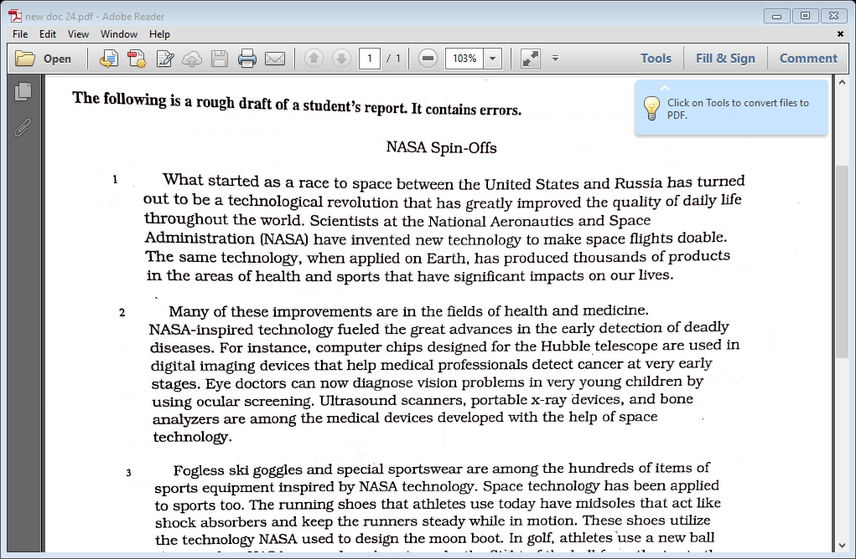

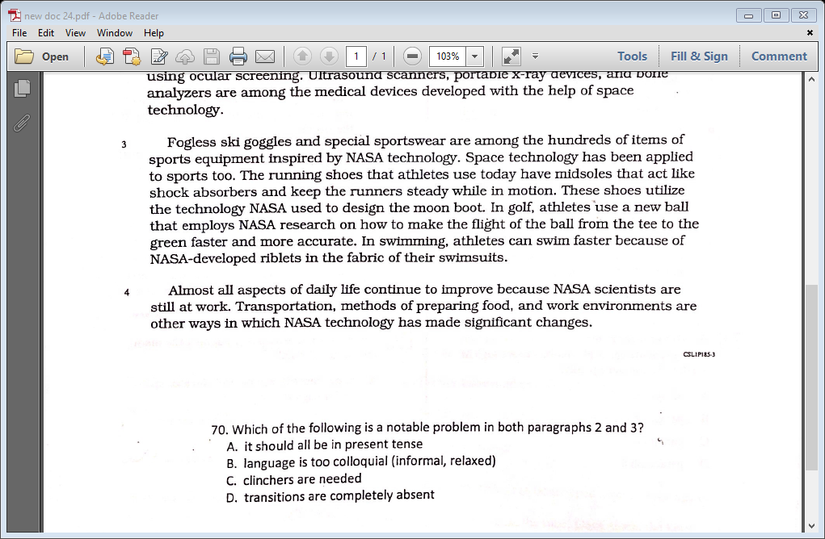

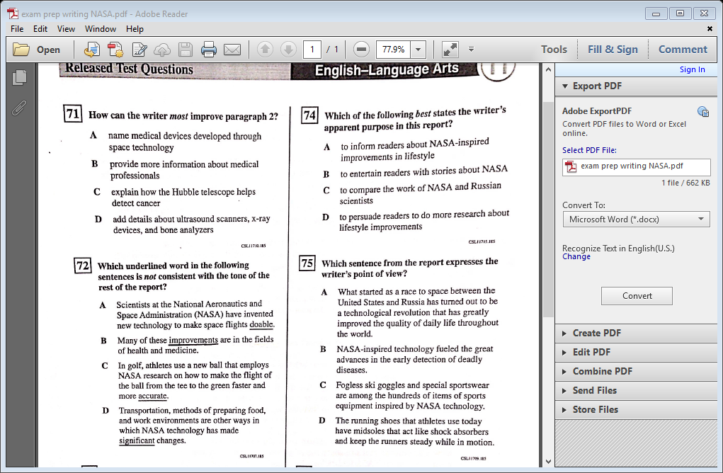

“Doable” is too benign; the other words are more positive

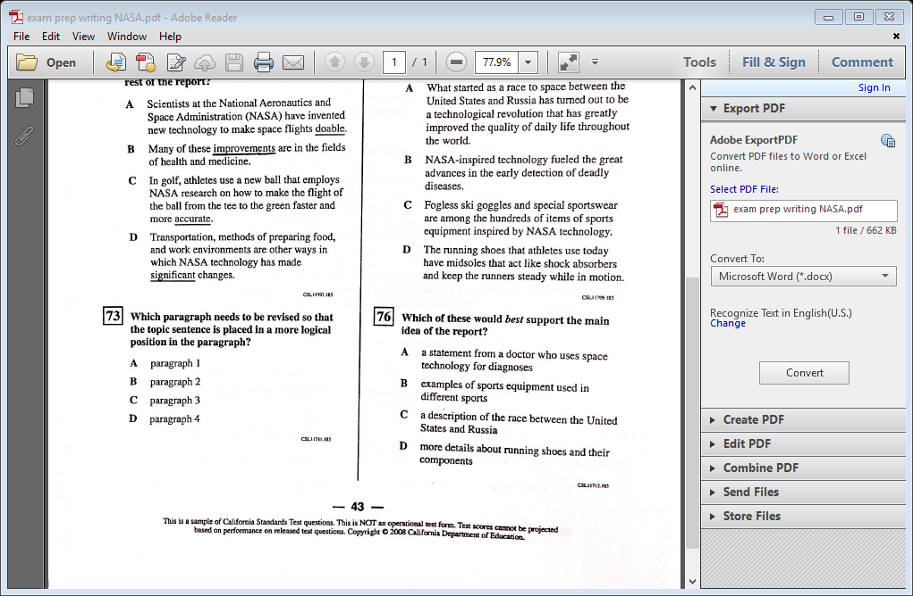

76. A. An expert would SUPPORT a statement

B. these examples were already addressed

C. this is irrelevant to advancement

D. it would develop but not SUPPORT

The second sentence “Space technology has been…” really is the topic sentence b/c it previews and transitions