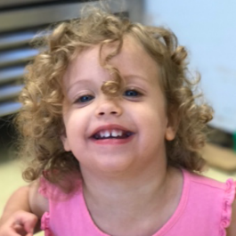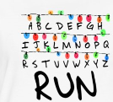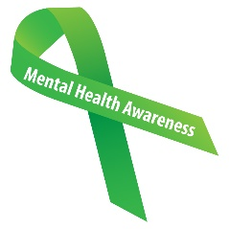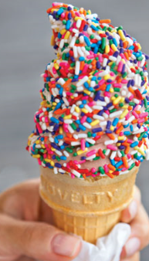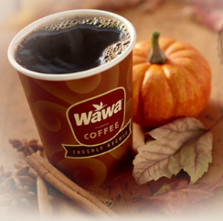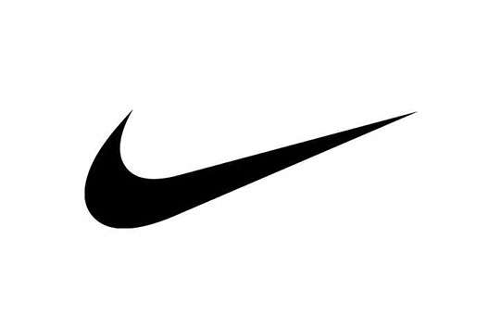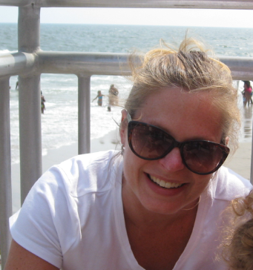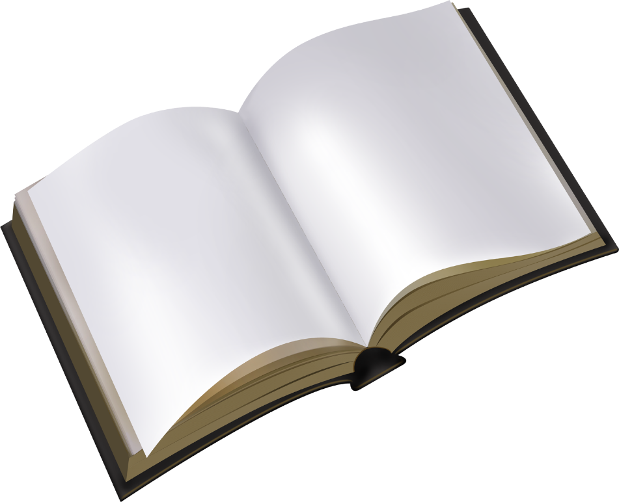

**TV SHOWS**: *Madame Secretary* (fills *The West Wing* void), *House of Cards* (maybe it isn’t so far-fetched?!), *Project Runway* (love the way they “make it work!” And I love the variety of models this season), *The Crown* (it’s hard to be a queen), *Stranger Things* (Eggos, anyone?). I love those political dramas that make me think about leadership and corruption, and I like the occasional fright factor that makes me jump.

**LOVE being an AUNT**: My niece, Emma, is almost 2, and I adore her. Every time she finishes lines to “What a Wonderful World,” or dances, or says, “Oh, Man!” or scribbles with a crayon or eats out of the dog’s bowl, I laugh. When she calls me “Bestie,” I melt. I feel a sense of responsibility and excitement that I get to play a role in her life and can’t wait to introduce her to the arts!

**SURPRISE**: I really enjoy working out, especially weight training. I see a trainer once a week, and he kicks my butt. I like the physical challenge because it makes me feel strong—I can deadlift 115 lbs! I also like the stress relief, and faced with media pressure about female “perfection,” I like to try to feel that I look healthy. PS-I love hip hop and old school gangsta rap for cardio!

**BOOK**: I’m just about finished *Shoe Dog* by Phil Knight, the founder of Nike. His account of growing his company and sales is inspirational, and I like his reflections about his staff, his product, his brand, and his management style. I’m a loyal fan of Asics, but after this book I might go ahead and try a pair of Nikes.

**FAMILY TRADITION**: Every summer my family goes to Sea Isle, and one night we eat our way across the OC boardwalk: Manco & Manco’s pizza, Johnson’s caramel corn, and Kohr Brothers’ ice cream (vanilla with rainbow jimmies, please). The indulgences define vacation—a treat, a break from the routine. I also enjoy the laughs over melting ice cream, sticky fingers, and food stains!

🎔 **FALL**: I love candy corn, but it has to be Brach’s harvest blend—love those little pumpkins. Yum on caramel apples—with peanuts. Haunted hayrides/houses make my heart race, but I like that anticipation of the scare. And I look forward to WaWa’s pumpkin spice coffee. Coffee is already a food group for me, and pumpkin spice is comfort in a cup!

**SOCIAL ISSUE**: All of them? I’m a little addicted to CNN. One thing I care about is mental health. There is still a stigma around people who struggle with a mental issue, and I wish society would commit to less judgment and better care, resources, and support. Young people, especially, need to know it’s okay to talk about difficulties; it’s okay to seek help.

Get

To

Know…

**Ms.**

**Remar**