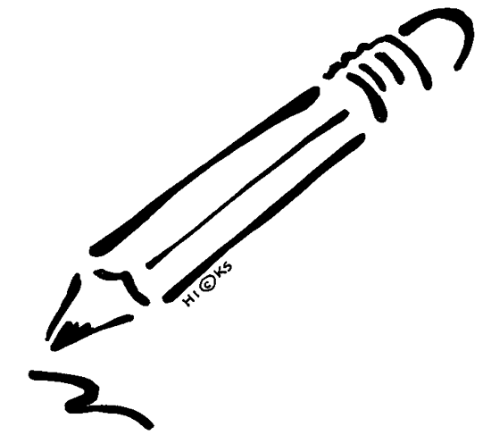Mrs. Moriarty

hmoriarty@cbsd.org

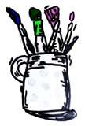**Welcome to Drawing and Painting 1! This course is open to all students who enjoy two-dimensional work. Emphasis is placed on developing basic drawing and painting skills and techniques. A variety of media will be used in class. The fundamentals of composition as found in the elements and principles of design will be used when drawing and painting from life and imagination, using realistic and abstract themes.**

I. MATERIALS NEEDED:

* 9” x 12” (minimum size) sketchbook: spiral or bound
* Number two pencils
* Kneaded erasers
* Canvas for final painting unit
* Shallow Tupperware container for paint (approx. 5”x 8”)

II. COURSE CONTENT:

In this course, we will cover major topics/units. These will include, but are not limited to:

Unit 1 – Line (Observation/Perspective) Unit 3 – Value

Unit 2 – Composition/Texture Unit 4 – Color/Acrylic Painting

III. EVALUATION AND GRADING:

All art projects will first be evaluated by the student and then by the teacher. I will take into consideration your evaluation and feedback when producing your final grade for each project. You will be evaluated in three major areas:

1. Responsibility (10%): Students an earn 2 points everyday. To receive full credit, be on time, be present, work diligently the entire period, show interest, demonstrate effort by going beyond the basic assignment, and clean up after yourself! If you are late, you will lose daily credit (one point). Students’ attentiveness and attitude are taken into evaluation and can/will effect their grade.
2. Projects/ Classwork /Sketchbook (90%): All required assignments/projects will be successfully completed as described by assignment handouts. All assignments will be turned in for assessment, and all *major* projects will be assigned a point value. Smaller assignments will be given an individual point value as well. All objectives will be based on concepts taught, composition/design, technique and studio/working skills. This is an activity-based course, so *active* participation will be imperative by you, the student!

Every student will be responsible for completing all assigned readings, questionnaires, worksheets and sketchbook assignments. Sketchbook assignments will be due weekly. They may be handed in the next day for partial credit. After this day, sketchbook assignments will not be accepted.

IV. PROJECT DUE DATES:

All projects will have a due date by which they will be due to be turned in. Some projects will be given a due date half way through the assignment as each class works at different rates. If you have an excused absence, one extra day is allowed for each excused absence, with the understanding that the project will be made up after school or at home. It is your responsibility to find out about missed assignments.

*** 5 points will be deducted for each day a project is late without an excused absence.

IV. CLASSROOM RULES:

Students are to exhibit courtesy and respect to the teacher and to their peers at all times.

1. BE ON TIME!

2. Be prepared for class.

3. Respect both teacher and fellow classmates.

4. Respect all art materials, projects and opinions.

5. No eating or drinking in the art room. Only bottled water with a lid is allowed.

6. No cell phone use!

7. Clean up your entire work areas at the end of class.

8. Keep talking to a *quiet* minimum…use your energy for creating art!

9. Be creative, challenge yourself, and have fun!!

Student Signature: _______________________________________

Date: ________________

Parent Signature: ________________________________________

Date: _______________