4.6 from 38 reviews

VEGAN GREEN CHILI MAC N CHEESE

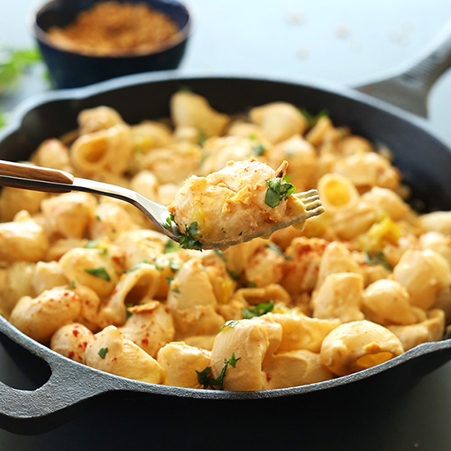

[PRINT FRIENDLY VERSION](http://minimalistbaker.com/easyrecipe-print/7777-0/" \t "_blank)

**Prep time**

10 mins

**Cook time**

20 mins

**Total time**

30 mins

10 ingredient, 30 minute vegan mac n cheese infused with green chili and topped with crispy baked crushed tortilla chips!

Author: Minimalist Baker

Recipe type: Pasta

Cuisine: Vegan

Serves: 4

Ingredients

* 10 ounces large macaroni shells (gluten free for GF eaters | I used pipe rigate)
* 1/2 white onion, diced
* 3-4 cloves garlic, minced
* 1 cup raw cashews, soaked for 4-6 hours or overnight, then drained
* 1 1/2 cups vegetable broth
* 1 Tbsp cornstarch
* 1/2 tsp cumin
* 3/4 tsp chili powder
* 2 Tbsp nutritional yeast
* 1 4-ounce can diced chills (scoop half into the sauce, reserve half for the finished mac n cheese)
* Optional: 1 cup tortilla chips, fresh cilantro for topping

Instructions

1. If topping with tortilla chips, crush chips into fine crumbs and add to a baking pan lined with parchment paper or foil. Spritz with olive or canola oil, sprinkle with salt and stir, then bake in a 350 degree F oven for 10 minutes or until golden brown.
2. Boil macaroni according to package instructions.
3. In a medium skillet over medium-low heat, sautee onion and garlic in a bit of olive oil. Season with salt and pepper, stir and cook until soft and fragrant – about 7 minutes. Set aside.
4. Add onions and garlic to a blender with remaining ingredients, omitting the tortilla chips and adding only half of the green chilies. Blend until smooth, using the “liquify” setting if you have it to get it really smooth. Otherwise just blend for up to a minute, scraping down sides as necessary, until smooth and creamy.
5. Drain the noodles, set aside and cover (with a towel). To the same pot you boiled the noodles in, add the cashew cheese and cook on low stirring frequently until slightly thickened.
6. Add the macaroni noodles to the cheese, along with the remaining green chilies and stir. Serve immediately, topping with crushed toasted tortilla chips and cilantro (optional).

Notes

\*Adapted from the amazing[Isa Chandra.](http://www.theppk.com/2013/06/chipotle-mac-cheese-with-roasted-brussel-sprouts/" \t "_blank)  
\*Nutrition information is for 1 of four servings without tortilla chips.

Nutrition Information

Serving size: 1/4 recipe Calories: 516 Fat: 17g Saturated fat: 3.5g Carbohydrates: 72gSugar: 4g Sodium: 380mg Fiber: 5.6g Protein: 19g