**The Thirty Years War: 1618-1648**

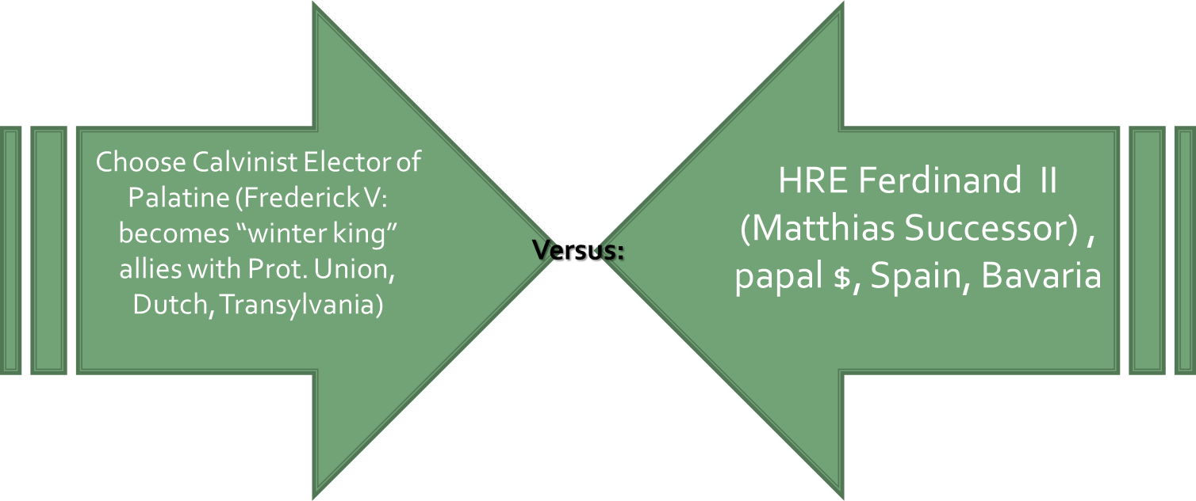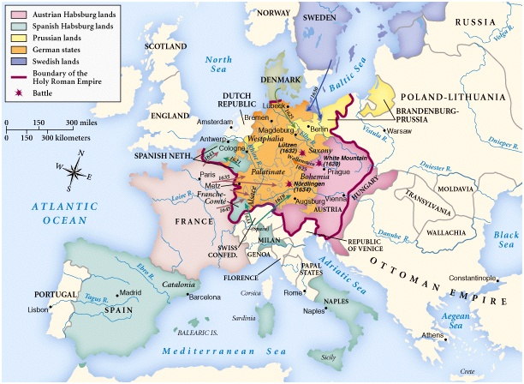 **Battle of White Mountain (1620)**

**Battleground - Germany:**

**Background of the War:**

* Lutheran Gains
* Why so complex?

**WAR: 4 phases**

* **1st Phase: The Bohemian/Czechs (1618-1625)**
* 1618 Explain *Defenestration of Prague*

Consequences:

**Result**

* **2nd Phase: The Danish (1625-1629)**
  + Describe events and people

How is Wallenstein assassinated?

* **3rd Phase: The Swedish (1630-1635)**
  + Richelieu pays Lutheran, Swedish king _________________ to fight Catholic League
  + Helped by Saxony, Dutch, and fearful German princes who fear imperial centralization
  + Swedish Arms wins @
  + ________________ hates Spanish influence, stops fighting for HRE
  + Saxons decide to abandon ship and sign Peace of Prague (______) and are joined by other German Protestant states
* **4th Phase: The Swedish-French (1635-1648)**
  + _______________ publicly aides __________ and Protestants, hires Bernard of Saxe-Weimer
  + Fight around Rhine River
  + ______________ attacking FRANCE from Belgium
  + Portugal and Catalonia rebel from ______________; are recognized as independent by France
  + French able to get as far as Pyrenees

Outcome:

**The Peace of Westphalia - 1648**

1. Lengthy Peace Negotiations
2. Dissolution of HRE
3. Germany Fragmented
4. Staatensystem

**EQ: What were the long-range effects of the Thirty Years War?**