AP European History
The Renaissance in Italy Name: _________________
1

Renaissance
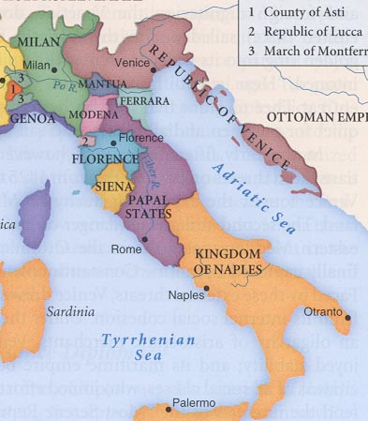
Characteristics:

5 Ideals of the Renaissance: {In your own words, what do they mean to you.}
- Humanism –
- Secularism –
- Individualism –
- Rationalism –
- VirtÚ –
Italian
City - States

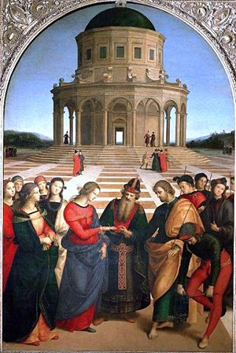
What values can we extract (figure out) from the pictures below?

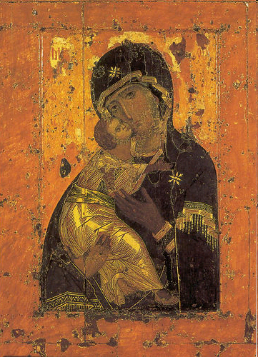
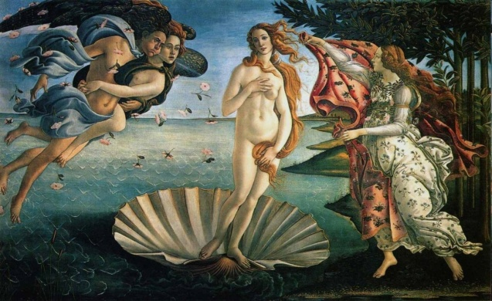

Who is Filippo Brunelleschi?

Humanism:
Other Humanists:
Boccacio:

Brunni:

Della Mirandola:

Renaissance Culture and Life:
- EDUCATION: ________________________________________________
Baldassare Castiglione’s- The Courtier “Let the man we are seeking be very bold, stern, and always among the first, where the enemy are to be seen; and in every other place, gentle, modest, reserved, above all things avoiding ostentation {showiness} and that impudent {bold} self praise by which men ever excite hatred and disgust in all who hear them.”
Machiavelli - Should a leader rule like a lion or a fox?

Lingering Questions:
- What are the contributions made by Machiavelli to politics and political thought.

- What motivated his writings?

- How would you evaluate his conclusions?

Renaissance Art
Art & Patronage:

Characteristics:
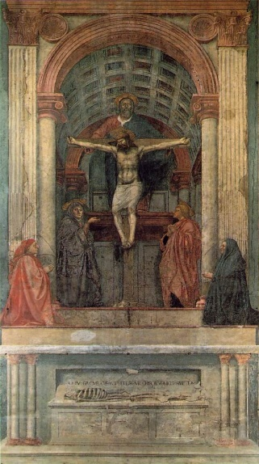
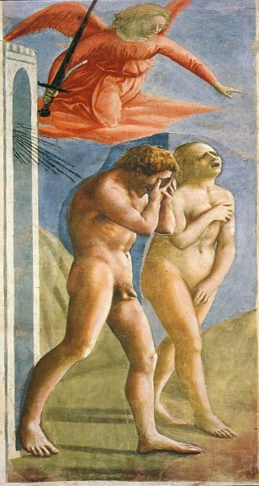

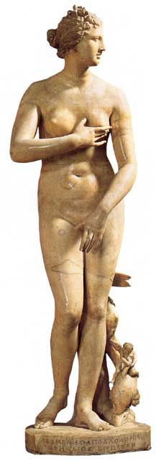


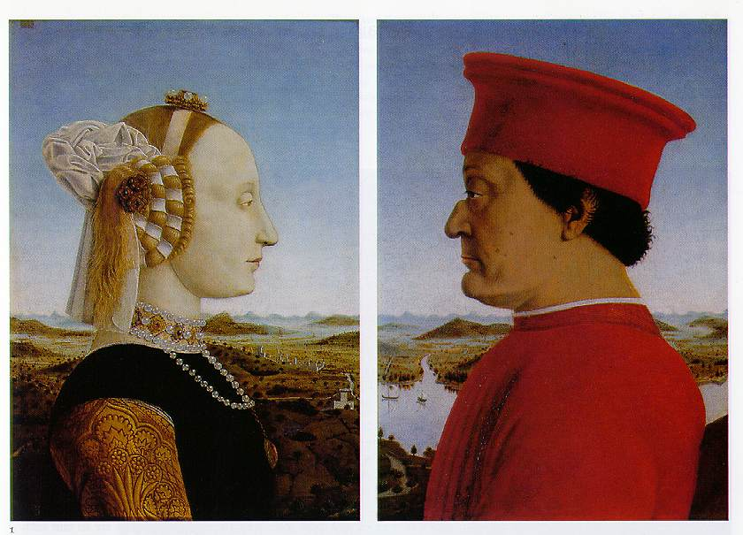
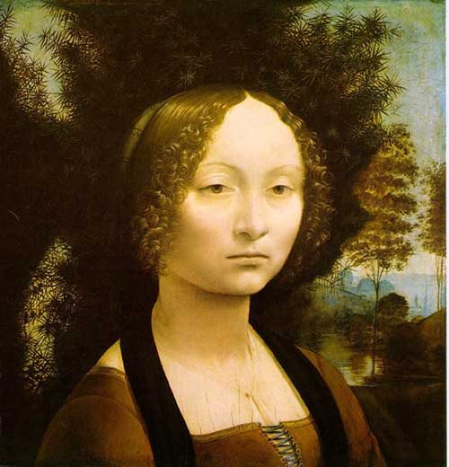

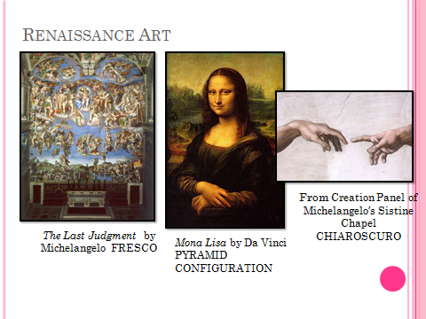
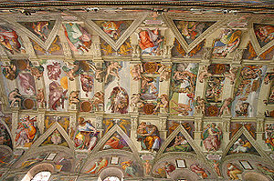

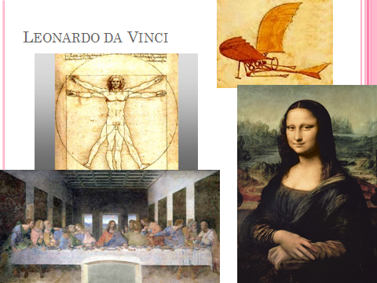

Comparison between the Middle Ages and the Renaissance:

Versus

Versus
Essential Question:
What characteristics of Italy, mainly Florence, can explain the “burst of creativity” demonstrated there from the 14th -16th centuries?

The Renaissance Outside Italy – Northern Renaissance, Section 7

Differences…

Similarities…

Albrecht Durer, “The Hare”
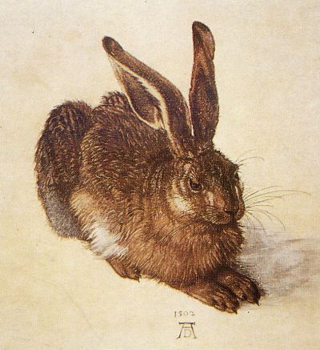
Northern Renaissance
More intellectual:

Define Mysticism:

Critics who call for reform… Brothers and Sisters of the Common Life
Northern Humanists

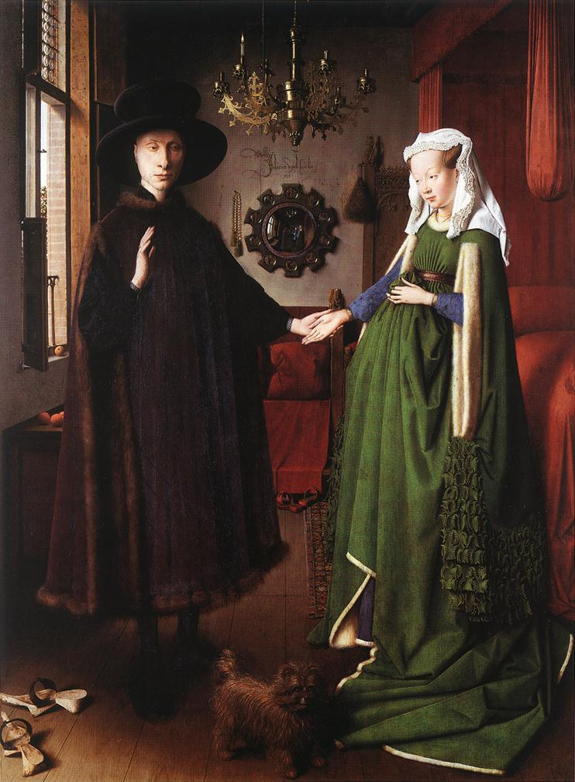
Flemish Painters of the Low Countries

List the details associated with this paintings.

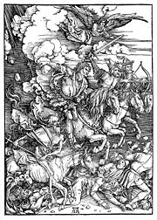
German Painters
List any paintings or characteristics you notice by the painters.

- Albrecht Durer
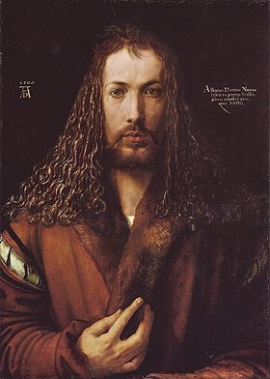

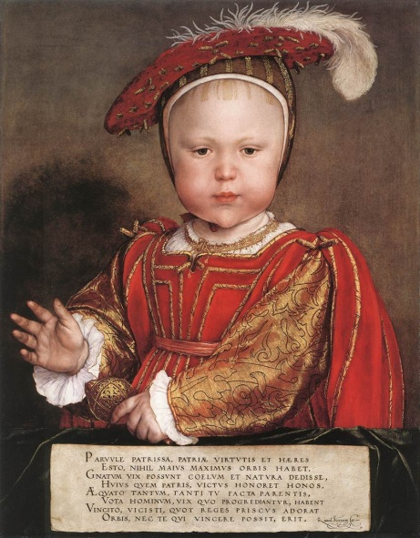
- Hans Holbein the Younger
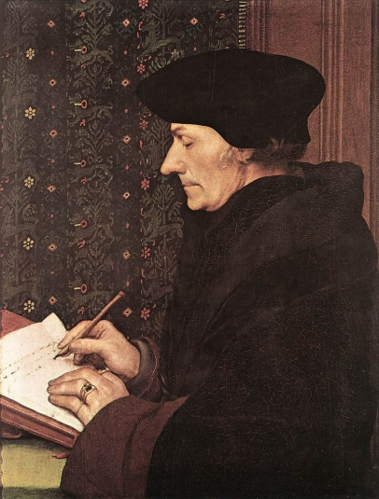

----------------------------------------------------------------------------------------------------------------------------------------------------------------
The New Monarchs –Section 8
Definition:

Characteristics
- Unification and consolidation of a nation
- Control or reform of legal system
- Solidifying of hereditary monarchy
- Suppression of opposition, esp. nobility
- Guarantees of domestic peace

