***The Spanish Wars of Religion****: Crusades against the Dutch and English*

**Charles V rules ALL, spent 35 years to preserve religious unity in Germany -> abdicated HRE and went to monastery in 1556**

[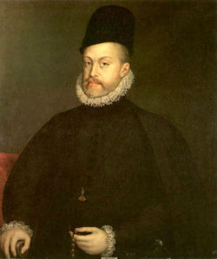](http://en.wikipedia.org/wiki/Image:PhilipII.jpg)[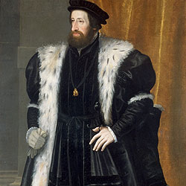](http://en.wikipedia.org/wiki/Image:Ferdinand_I_(1503-1564).jpg)[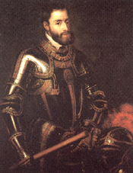](http://en.wikipedia.org/wiki/Image:Emperor_charles_v.png)

What is happening contemporarily?

* Philip II
  + Ambitions:
* Revolt in the Netherlands – 1566

**North**: German Dialects

**South**: French

* + ______Nobles asked to not be involved with Spanish Inquisition -> Spain ________!
  + Protestants pillaged 400 churches
  + Philip sent Alva with Council of Trouble (Council of Blood)

1. –
2. –
3. –

[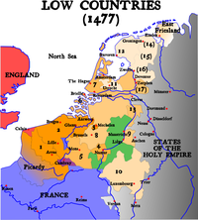](http://en.wikipedia.org/wiki/File:Map-1477_Low_Countries.png)

* Who does England support?

**England’s Involvement**

* Union of Utrecht - 1579
* United Provinces of the Netherlands - 1589
* England – Bullwark of Protestantism

**Spanish Armada - 1588**

Details:

1588: Philip sends troops with Parma to blockade the Netherlands, & they were prepared to invade England, if necessary

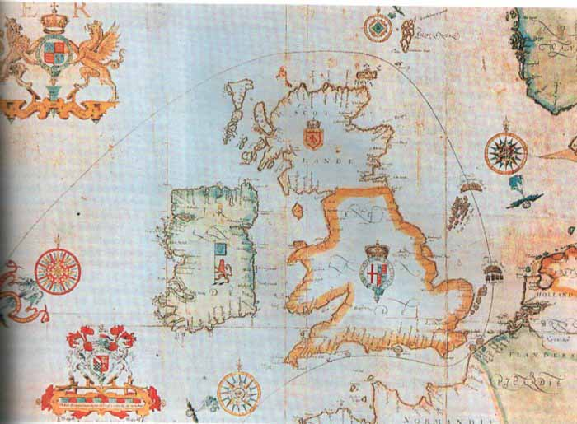

**North:** 7 provinces- DUTCH

**South**: Spanish Netherlands

* **Results of the Struggle:**
* **Elizabeth I: The Virgin Queen**

**Resolutions**

**Conflicts**

* Accomplishments –
* Legacy –