Unit 2 Enduring Understanding:

Chaotic periods often result in a general pattern of increased governmental power.

*Essential Question: What are the characteristics of 17th Century absolute monarchy in France?*

**Section 26: Peter the Great**

***Russia before Peter the Great***

**Parallels with Prussia:**

**Europeanization:**

Examples of Estrangement from Europe:

Consequences:

Define ***Serfdom:***

* Uprising – 1667: Revolt!

= Slave Plantation

[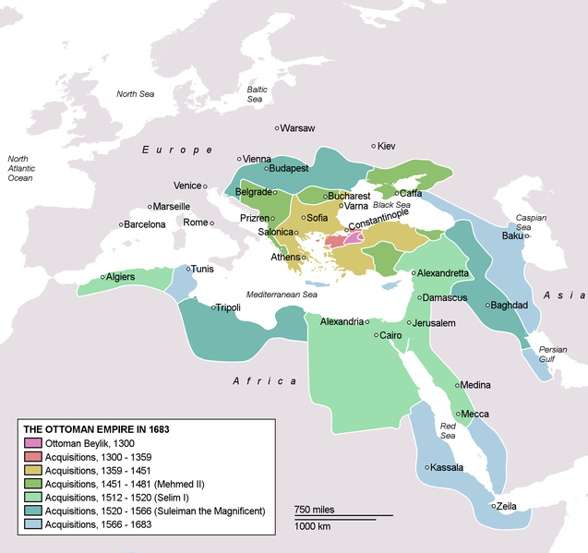](http://upload.wikimedia.org/wikipedia/commons/0/06/OttomanEmpireIn1683.png)

OLD BELIEVERS:

* Foreign Policy and Expansion:
* Exposure to the West:
* Polish Threat Recedes:

**Peter the Great**

**Reign:**

* **The Great Northern War (1700-1721):**
  + 1697: Charles XII becomes Swedish king
  + 1700: Battle of ________. Swedes clean up.
    - Instead of using advantage against Russians
      * Swedes sweep Poland, elect Swedish king.
  + 1709: Swedes turn to Russia (and their winter). Peter has reformed army. Battle of ________gets rid of leftover Swedes
  + 1721: Treaty of _________ – Russians get Baltic possessions

List some changes made by Peter:

* Reforms of the Military
* Get rid of Streltsi =
* Import Foreigners

**Peter the Great**

**Reign:**