Unit 2 Enduring Understanding:

Chaotic periods often result in a general pattern of increased governmental power.

*Essential Question: What are the characteristics of 17th Century absolute monarchy in France?*

**Section 17: The Grand Monarque and the Balance of Power**

* **Balance of Power: 3 Ways to Look at it…**

1. **–**
2. **-**
3. **–**

**France in the 17th Century**

**Statistics: Population Patronage of art:**

**Inequalities: Salons of Paris:**

Principal Theorist:

ABSOLUTISM – Monarchy:

* Definition –
* Justified through idea of **DIVINE RIGHT**—idea that God created the monarchy and the monarch acted as God’s representative on earth

**Rise of Absolutism in France:**

* 17th Century France
  + Pinnacle (height) of power, wealth, and prestige
  + Oversees exploration and expansion
  + Cultural and intellectual world leader
* Forms of Authority

Aftermath:

**The Absolute of Louis XIV**

* + _______________________________________________________________
  + Heavily _____________ his people to build his Palace of Versailles and instigate costly wars
  + 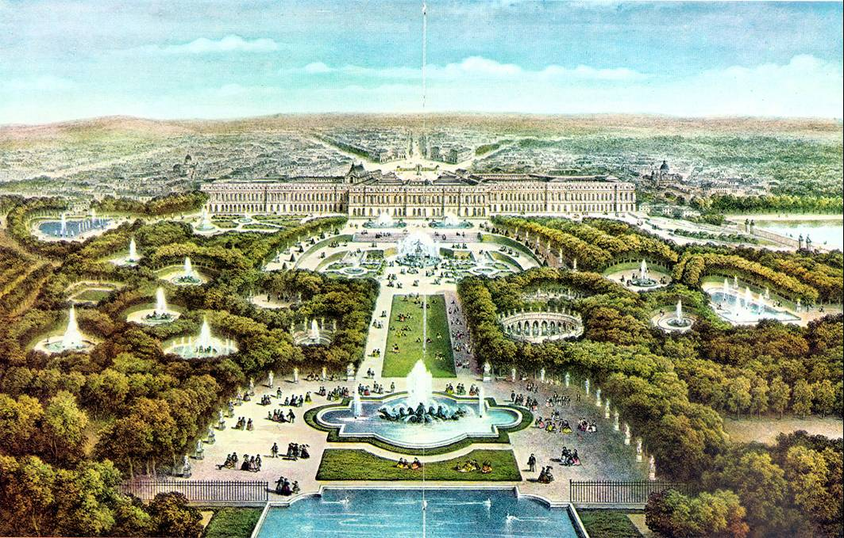Declining economy due to high expenses
  + Limited power of nobility by promoting positions of newer upper-middle class
  + Called________________
* Government and Administration
  + War ->
  + Describe Palace of Versailles:

**A Day in the Life of Louis XIV: The Sun King (Reign: _____________________ ) Famous Quote:**

*What does it mean?*

* Economy and Finances – JJ Colbert

Taxation:

The Five Great Farms:

Colbert’s Commercial Code:

* Religious Unity – Revoked Edict of Nantes

Describe Versailles:



*Essential Question: What were the domestic and foreign policy goals of Louis XIV? Assess his success or failure in achieving these goals.*

## The Wars of Louis XIV

* **The War of Devolution (1667)**
* **Dutch War (1672)**
  + **French attack Dutch provinces on the lower Rhine.**
  + **William III of Orange (Dutch stadtholder) allied himself with the Austrian and Spanish Hapsburgs, Brandenburg (Prussia), and Denmark.**
  + **Results:**
* **The War of the League of Augsburg (1688-1697)**

**List the contenders:**

Holy Roman Empire

* 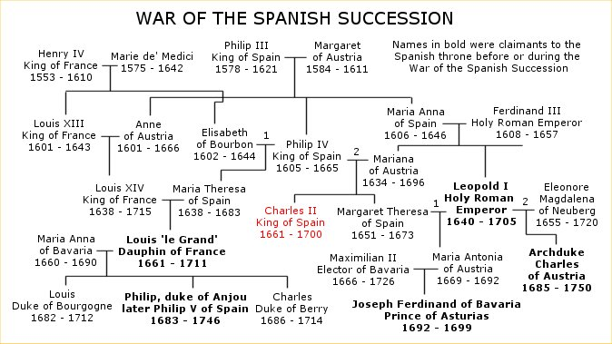**The War of the Spanish Succession (1702-1713):**
  + Roots & Causes:

*Agreements were reached to split the inheritance, but upon death of Charles II it was found that he had made a will….*

1. Spanish Empire left in place
2. Inheritance:
3. If refused:

*Louis accepted, but many in Europe saw this as a real threat to the balance of power in Europe, which was now in France’s favor.*

**RESULT: The Peace of Utrecht (1713-1714)**

1. British get Gibraltar and Minorca, New Foundland, Nova Scotia and Hudson Bay territory.
2. Ruler of Savoy becomes _________________________
3. ___________________________________ becomes King of Prussia
4. Austrian Hapsburgs get _________________________
5. Spain hold American Possessions:
6. Dutch receive guarantees of their security…

Establishes:

Assured the British a line of Protestant kings and the maintenance of parliamentary and constitutional government.