Explorers,

AP Euro Homework Assignments

{Sections 11-16}

DATE: 12/01/14

TOPIC: Review

1. Unit 1 Review – Chapter 1 & 2

HOMEWORK:

1. Study

---------------------------------------------------------------------------------------------------------------------------------------------

C:\Users\adicks\AppData\Local\Microsoft\Windows\Temporary Internet Files\Content.IE5\CFTHB9SJ\MC900251265[1].wmfDATE: 12/02/14

TOPIC: Exam

1. Unit 1 Exam – Chapter 1 & 2

HOMEWORK:

1. P/C pp. 97-104: Section 11

(The Opening of the Atlantic)

______________________________________________________________________________

DATE: 12/03/14

C:\Users\adicks\AppData\Local\Microsoft\Windows\Temporary Internet Files\Content.IE5\YHXCOLWI\MC900150095[1].wmfTOPIC: “Columbus –Hero or Villain?”

1. Section 11 Study Guide
2. Lecture on Exploration
3. Reading on Columbus – Read and take notes
4. Class discussion of articles

HOMEWORK:

1. P/C pp. 104-112: Section 12

(The Commercial Revolution)

1. P/C pp. 112-118: Section 13

(Changing Social Structures)

___________________________________________________________________________________________

DATE: 12/04/14

TOPIC: "Commercial Revolution" & “Changing Social Structures”

1. Discuss Questions and Terms
2. Lecture on Commercial Revolution
3. Commercial Revolution Activity
4. Lecture on Changing Social Structures

HOMEWORK:

1. P/C pp. 118-127: Section 14

(The Crusade of Catholic Spain: The Dutch and English)

______________________________________________________________________________

DATE: 12/05/14

[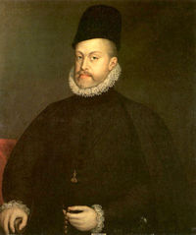](/wiki/Image:PhilipII.jpg)TOPIC: "Philip II – Catholic Bulwark"

1. Discuss questions and terms
2. Lecture on Philip’s Spain
   1. Religious Struggle
   2. Relations with Tudor England
   3. Defeat of the Armada
3. Philip II Article: Read and take notes

HOMEWORK:

1. P/C pp. 127-133: Section 15

(The Disintegration and Reconstruction of France)

______________________________________________________________________________________________

DATE: 12/08/14

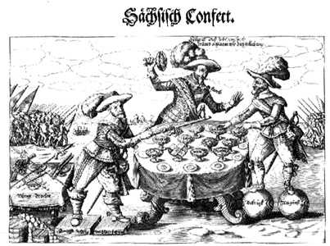

TOPIC: "Queen Elizabeth"

1. Discuss questions and terms
2. Queen Elizabeth Documentary
3. Writing Discussion
4. Start Absolutism in France

HOMEWORK:

1. P/C pp. 133-139: Section 16

(The Thirty Years’ War, 1618-1648: The Disintegration of Germany)

__________________________________________________________________________________________________

DATE: 12/09/14

TOPIC: "French Civil Wars of Religion" & "Thirty Years War"

1. Lecture on the absolutism in France.
2. Lecture on the Thirty Years War.
3. Student pairs will complete Thirty Years War activity : Review of activity and debriefing

HOMEWORK:

1. Study for Chapter 3Exam

__________________________________________________________________________________________________

DATE: 12/10/14

TOPIC: Review

1. Review Chapter 3

HOMEWORK:

1. STUDY for Exam tomorrow!!!

__________________________________________________________________________________________________

DATE: 12/11/14

TOPIC: Chapter 3 Exam

1. Chapter 3 Exam

HOMEWORK:

1. P/C pp. 143-147: Section 17

(*The Grand Monarque* and the Balance of Power)

1. P/C pp. 167-179: Section 21

(The France of Louis XIV, 1643-1715: The Triumph of Absolutism)