***Enduring Understanding****:*

*Challenges to the social, political, economic, religious, scientific, intellectual, and artistic order frequently come from new ideas.*

Essential Questions:

1. What were the essential causes of the Commercial Revolution?

2. How was the Age of Exploration an extension of the Renaissance?

3. What role did the Age of the Wars of Religion play in the lives of absolute monarchs?

**Background**: 1560-1648: Age of Wars of Religion -> Ended by Peace of Westphalia

List the nations that had to deal with internal strife and religion issues:

Time of Economic Renewal – Global Economic Society Expands from

Opening of the Atlantic, Commercial Revolution, and new social classes.

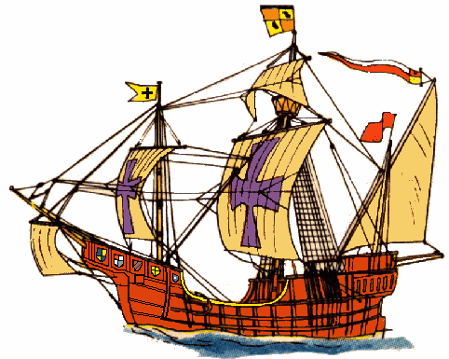

* Why was the Atlantic found?
* How was this possible?

**Lead to a _____________________**

* Spain & Germany weakened
* English, Dutch, French rise

Migration of people

World wide trade

Cross culture encounters

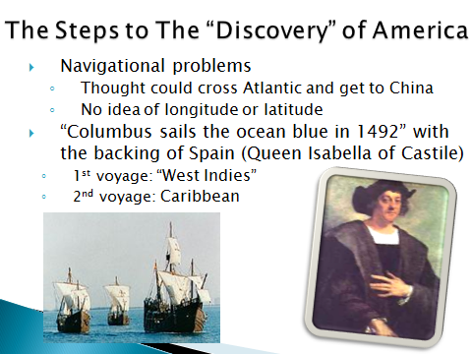

**Portuguese in the East**

* Prince Henry the Navigator ▪ Bartholomew Dias

15th Century - 1488-

* Vasco da Gamma

1498 -

*Key Term: Conquistadores –

**Spanish Empire in America**

*Key Terms:*

~Encomienda System

~Creoles

~Mestizos

**Conquest Phase:**

Cortes and Aztecs in Mexico

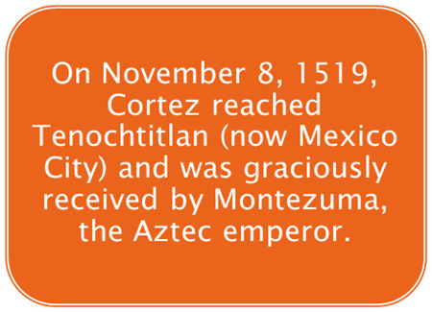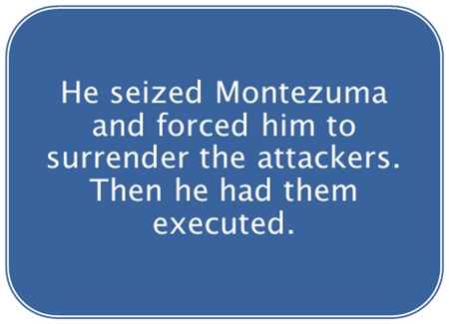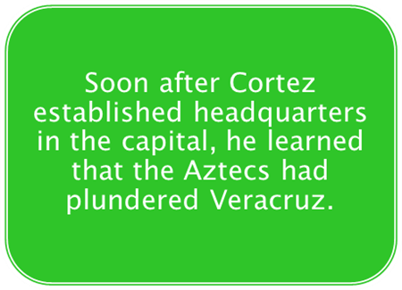

* Magellan’s boldness in 1520
  + Spanish Expedition finds a southwestern passage of Atlantic into Pacific
  + Circumnavigates the _______________
* Spanish/Portuguese agreement: 1494 ___________________________________
  + Globe is divided in an imaginary north and south line

**The Spanish Empire in America:**

* Educational Advances -
* Potosi, Peru: Silver Mines -