Unit 1 Enduring Understanding:

Challenges to the social, political, economic, religious, scientific, intellectual, and artistic order frequently come from new ideas.

***Why is Charlemagne important?***

|  |  |  |
| --- | --- | --- |
|  | **Feudalism:** | **Description:** |
| The Manor | *Definition:* |  |
| Economy |  |
|  |  |  |
| Evolution of Town Life | Farming |  |
| Towns & Fairs |  |
| Guilds | **Examples:** |
| Rights |  |

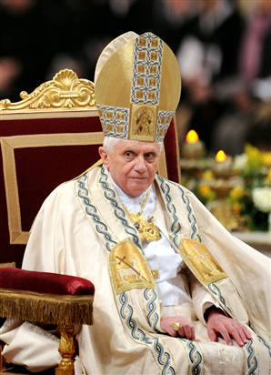

**Medieval Catholic Church**

* Reforms and Abuses ▪ Power of the Pope:
  + The Pope - 1. Excommunication

2. Cannon Law

* + No more **simony** -

* + **Lay Investiture** Banned -

**Major Events of the Middle Ages:**

Crusades

**d**  
Crusades

**Effects of the Crusades…**

1. Eastern culture and knowledge
2. Religious bitterness

( )

1. Italian business spreads

**Other Crusades…**

1. Arabs out of Sicily (1100).
2. _____________________________.
3. Knights Templar expel pagans in Baltics.

**Crusades (1095-1270)**

* 8 official papal crusades to recapture Jerusalem
  + Causes:

1. Bring Turks back into “the fold”.
2. ________________________

* Other Purposes:

1. ______________
2. ______________
3. ______________

**The Road to Knighthood**

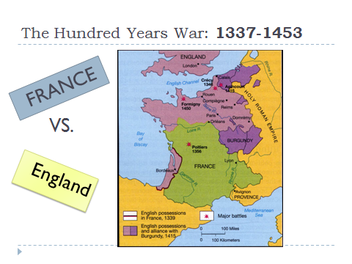 Causes:

* Land Issues-
* Controversy over Succession-

Results:

**The Church of 14th and 15th Century**

1302: Unum Sanctum: __________________________

____________________________________________

* Implication:
  1. Spiritual over temporal leaders
  2. Clergy pay no taxes

1302-1378: Babylonian Captivity

* King Philip (IV) the Fair of France sent soldiers to pick up Boniface

1378: Schism of the West

* Factionalized College of Cardinals:

_________________________________________________________________________________________________________________________________________________________________________

**1409 begins the Conciliar Movement**

1438: Pragmatic Sanction of Bourges and the Gallican Church

* Result: Papacy lost influence in France

1449: Council of Basel ends -

1450: Jubilee Year

1409: Council of Pisa -

1414: Council of Constance

* **Goals:**

1. Crush heretics (kill Huss and Wyclif)
2. End Schism: Martin V
3. Reform the church…

Corruption:

* **Simony:**
* Mistresses
* **Nepotism:**
* **Indulgences:** an excusal from purgatory if you have confessed and repented that you buy from the church

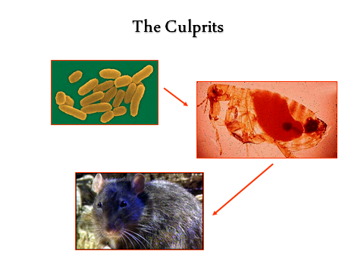[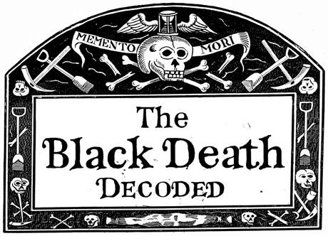](http://www.google.com/url?sa=i&rct=j&q=the+black+death&source=images&cd=&cad=rja&docid=31auLZlXA8nq5M&tbnid=JIsg1o2U59RvHM:&ved=0CAUQjRw&url=http://www.nature.com/news/2011/111025/full/478444a.html&ei=MbluUtzFO4aqkQe9sYG4AQ&bvm=bv.55123115,d.eW0&psig=AFQjCNEUYPPm_MY56m2RhZkbpFAnhW9t1A&ust=1383074438666875)

**Bocaccio in The Decameron**

*The victims ate lunch with their friends and dinner with their ancestors.*

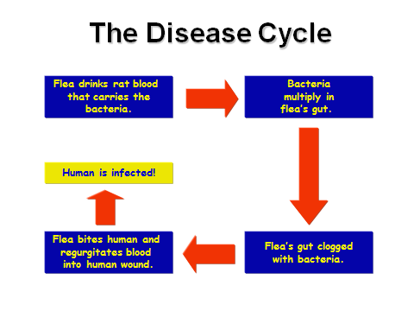

**Attempts to Stop The Plague:**

*Essential Question: What were the political, economic, and social effects of the Black Death??*