Unit 1 Enduring Understanding:

Economic changes in Europe, which in general signifies the rise of capitalistic economy and transition from a town-centered to a nation centered economic systems.

***Population Growth The Price Revolution***

***The steady rise in prices, also known as the steady decline in value of money, constituted a gradual inflation.***

**Changes in Commerce and Production:**

**“Putting Out System”:**

New Entrepreneurs

**d**  
Crusades

1. **Started as _______________ and ended up as _____________**

**IE:**

* **Weaver, who established a new cloth and then started dealing in spices**
* **Lent $ to popes and Charles** ______________
* **Became bankers to the Hapsburgs in Germany and Spain**

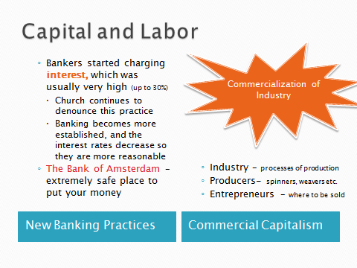

Leads to…

**Capital and Labor:**

Divergence Increased with factories

List the ***New Industries***:

England’s Goal:

**Mercantilism:**

*Define –*

* Opposition to Guilds
* Mercantilists oppose __________________________________
  + England’s guilds have little importance
  + France keep guilds for an easy tax

**Changing Social Structures:**

Social Roles

1. Education –
2. Government –

* Government helped to form social classes in the following ways: