**Collaborative Retrieval Practice Strategy: List-Pass-Amass**

One of my favorite review activities that I use with my high school science students is a strategy that I call List-Pass-Amass. This activity is flexible and can be done in an in person setting or virtually. This strategy can be used for basic recall, or it can be used to synthesize content. Students may work individually or in small groups.

**Classroom set up:**

I have black laboratory desks in my classroom that lend themselves to the use of chalk markers other options include big pieces of lined paper or large white boards. Depending on your purpose you might also use worksheets with a blank diagram (I sometimes use this when we are working on basic recall in my anatomy classes). Virtually, applications like [Microsoft Whiteboard](https://www.microsoft.com/en-us/microsoft-365/microsoft-whiteboard/digital-whiteboard-app) and [Jamboard](https://jamboard.google.com/) can be used.

**Example 1: Drawing tissues**

*Purpose: help students to recall the appearance of different types of human tissues, identify relevant structures in those tissues, and identify structure and function of each tissue type.*

* Task one: Students are put into partners and are asked to put all materials away; no resources should be used except for their own brain and the brain of their partner. Each student is given a chalk marker and the partner pair is given one 3x5 card that has the name of a specific tissue. Students are asked to draw their tissue as accurately and with as much detail as possible. They are not to label their tissue or any identifying characteristics.
  + Students rotate to their right, if they are at the end of a row they rotate back if they are in the back of the classroom they rotate to the front left corner.
* Task two: ask students to attempt to identify the tissue the previous group drew.
  + Students rotate to their right.
* Task three: ask students to attempt to identify the tissue at their current station, if they agree with the previous group, they place a check mark if they disagree they write a different answer.
  + Students rotate to their right.
  + Repeat task three.
  + Students rotate to their right.
* Task four: Ask students to identify one structure they see in the diagram (for example they might label the nucleus in a simple squamous cell).
  + Students rotate to their right.
  + Repeat task four.
  + Students rotate to their right.
  + Repeat task four.
  + Students rotate to their right.
* Task five: ask students to identify one location in the body where the tissue at their current station is found.
  + Students rotate to their right.
* Task six: ask students to identify the function of the tissue at their current station.
  + Students rotate to their right.
* Task seven: take a few minutes, place check marks next to any statements you believe to be correct, place an x by any statement you believe to be incorrect and make a correction.
  + Have students return to their starting station.

The teacher recaps the activity with students by going around the classroom and asking students what they originally drew and identifying any errors or misconceptions.

Here is an example of a desk at the conclusion of the activity.

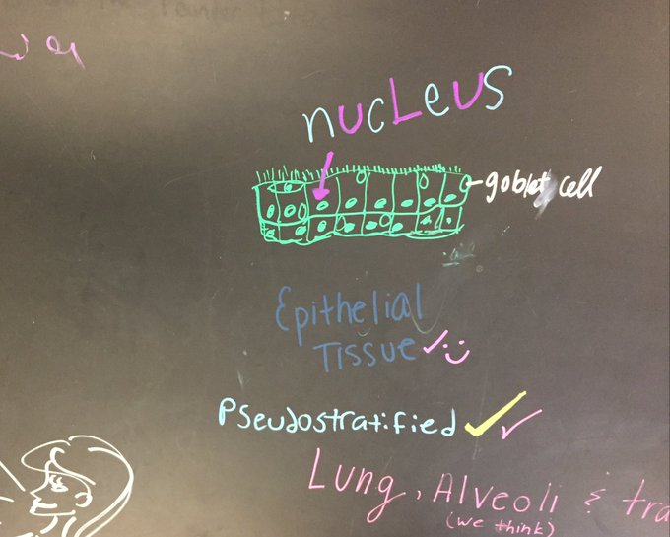

This activity can also be done using an application like Microsoft Whiteboard or Jam Board

**Example 2: Unit Review**

*Purpose: to have students to identify key information from unit lessons and to identify areas of weakness.*

* Task 1: Students are placed into groups of 3-4 depending on the size of the class and the number of distinct lessons in a unit. Each student group is assigned one “lesson” or “chapter.” Student groups use their notes to identify essential knowledge for their assigned lesson and then draft open ended questions which they write on their desk. I typically give students 10-15 minutes to complete this task and challenge them to think about what questions I will likely ask them on their exam.
  + When time is up students are asked to put all resources away.
  + Students rotate to their right, if they are at the end of a row they rotate back if they are in the back of the classroom they rotate to the front left corner.
* Task 2: Students have 5 minutes to answer as many of the questions at their new station as possible with as much detail as possible.
  + Students rotate.
  + Students repeat task 2 at their new station
* Task 3: Students are now asked to evaluate the answers at their new station. If they are unsure of an answer they mark it with a question mark, if they believe an answer is incorrect they draw an x next to it and provide an alternative answer.
  + Students can rotate again and repeat task 3 or students can return to their original station depending on the number of topics assigned.
* Task 4: Students can now access their notes again and check the responses of their classmates. A whole group review of the activity is helpful to identify any lingering misconceptions or missed key content information.

Sometimes I split the classroom in half, and they only rotate among their half of the room. When we are done, we compare what was done on the right side of the room compared to what was done on the left side of the room. Did students agree with the important topics? Can they defend their choices of questions?

Here is an example of student work at the conclusion of this activity:

