Graphing Freefall

For each situation, predict what the graphs will look like for a ball in freefall (ignore air resistance). Predictions are only for the ball when it is in the air, not when it is being touched.

- Ball being dropped
PREDICTED
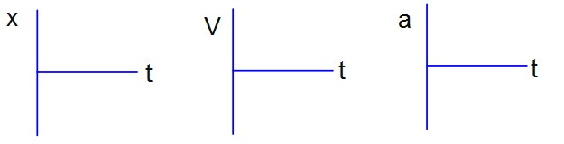
ACTUAL

- Ball being thrown up and then coming back down
PREDICTED
ACTUAL
- Ball being thrown down and bouncing back up
PREDICTED
ACTUAL

